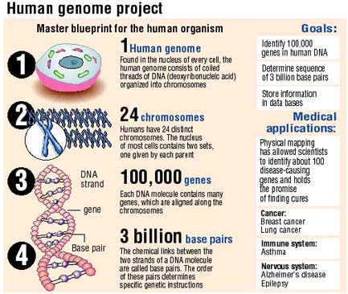
(Archives Star Bulletin, 2003)
Use the infographic, article and your previous knowledge to answer the following information:
- What does HGP stand for?
- Define Genome.
- Approximately how many base pairs are found in the human genome? That means there would be how many individual nucleotides?
- Those bases are divided into ____________________ genes that code for proteins.
- True/False: The goal of the HGP is to cure asthma.
Explain your choice.
- What is gene therapy?
- What is the difference between Somatic Gene Therapy and Germline Gene Therapy?
- True/False: Gene therapy may involve inserting genes or turning genes on or off.
- Describe a situation where scientists would want to use gene therapy to kill a cell.
- Describe ONE challenge to successful gene therapy.

Would You Want to Know the Secrets Hidden in Your Baby’s Genes?
Listen to the story at: http://www.npr.org/sections/health-shots/2016/10/27/499651062/would-you-want-to-know-the-secrets-hidden-in-your-babys-genes and answer the following:
- Define sequencing.
- Of what value is DNA sequencing?
- Thinking question: How does the Human Genome Project (HGP) relate to DNA sequencing?
- What is the experiment described here attempting to find out? How is it designed?
- What are some reasons why parents might want to know a baby’s DNA sequence? What are some reasons why they may NOT want to know?
- What are some ethical issues that surround DNA sequencing?

Would You Want to Know the Secrets Hidden in Your Baby’s Genes?
Listen to the story at: http://www.npr.org/sections/health-shots/2016/10/27/499651062/would-you-want-to-know-the-secrets-hidden-in-your-babys-genes and answer the following:
- Define sequencing.
- Of what value is DNA sequencing?
- Thinking question: How does the Human Genome Project (HGP) relate to DNA sequencing?
- What is the experiment described here attempting to find out? How is it designed?
- What are some reasons why parents might want to know a baby’s DNA sequence? What are some reasons why they may NOT want to know?
- What are some ethical issues that surround DNA sequencing?

Would You Want to Know the Secrets Hidden in Your Baby’s Genes?
Listen to the story at: http://www.npr.org/sections/health-shots/2016/10/27/499651062/would-you-want-to-know-the-secrets-hidden-in-your-babys-genes and answer the following:
- Define sequencing.
- Of what value is DNA sequencing?
- Thinking question: How does the Human Genome Project (HGP) relate to DNA sequencing?
- What is the experiment described here attempting to find out? How is it designed?
- What are some reasons why parents might want to know a baby’s DNA sequence? What are some reasons why they may NOT want to know?
- What are some ethical issues that surround DNA sequencing?

