Unit 3 Enrichment Activity 1: Science Comic
Take a look at the comic below:
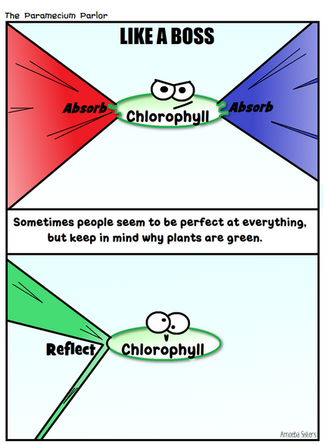
Source: Amoeba Sisters, http://www.amoebasisters.com/petunias-science-comics
- What concept is being illustrated by the comic above?
- Define the terms “absorb” and “reflect” based on their context in the comic as they relate to photosynthesis.
- Create your own science comic about one of the following topics from Unit 3: Cell specialization/differentiation, Cell cycle and mitosis, ATP as cell energy, Anaerobic Respiration, Aerobic Respiration, Photosynthesis, Leaf Structure.

