Unit 2: Biochemistry Review Stations
Station 1: Biochemical Families
Academic- Do the Macromolecule Worksheet
Honors-Do the Biochemistry Thinking Lab
Station 2: Polymerization
Together, we’ll watch the video at: https://collegeinfogeek.com/feynman-technique/
After watching the video and looking at the article and examples, use the Feynman technique to construct a study sheet to demonstrate the relationship between monomers and polymers, using examples for each of the biochemical families.
Station 3: Enzyme Function
Use the talk to the text technique to make meaning of the graphs on the sheet provided. Once you think that you understand each graph, write a claim about the data on each of the graphs as follows:
- Figure 1-Write a claim about the optimal temperature for each of the enzymes. Provide evidence from the graph to support your claim.
- Figure 2-Write a claim about the optimum pH for the two enzymes. Provide evidence from the graph to support your claim.
- Figure 3-Write a claim about whether or not enzymes are reusable. Provide evidence from the diagram to support your claim.
- Figure 4-Write a claim about the speed and energy of enzyme-catalyzed reactions compared to those without enzymes. Provide evidence from the graph to support your claim.
Station 4: Throwback Station
Identify the scientific names of the candies in the picture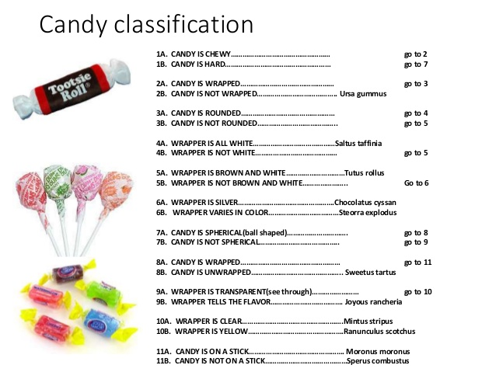
2. Draw a family-tree style diagram that shows how the 6 kingdoms of organisms are related to one another.

