Unit 2: Biochemistry Review Stations
Station 1: Biochemical Families
Academic- Do the Macromolecule Worksheet
Honors-Do the Biochemistry Thinking Lab
Station 2: Polymerization
Go to https://socratic.org/biology/molecular-biology-basics/organic-molecules-vs-inorganic-molecules/videos
Scroll down to the video Titled “Biological Molecules” (the 2nd video) and watch the first 5:50 minutes of the video then complete the polymerization worksheet
Station 3: Enzyme Function
- First, distinguish between enzymes and substrates on your paper.
Next, use the manipulatives at this station to do the following:
Reactions With and Without enzymes—
2. Using the PINK manipulatives, begin by showing how the substrate molecules would bond together without the enzyme. Would they be able to bond? Would it be fast or slow? Why? (Hint: use the term “activation energy” in your answer)
3. Now using the enzyme, demonstrate how an enzyme would assist in making the reaction between the two substrate molecules happen. What does an enzyme do for a reaction?
4. Look at the graph below:
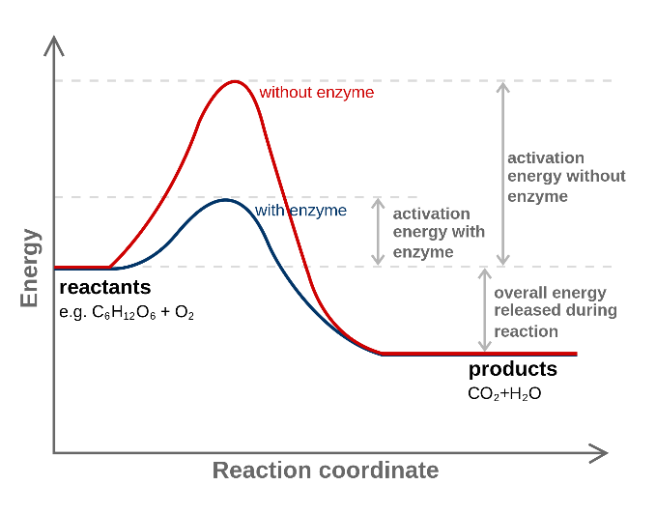
- Define activation energy
- What does an enzyme do to the activation energy? Why?
Enzyme Specificity--
5. Using the BLUE manipulatives, patch the correct substrates (A and B) to their appropriate enzyme (C and D). Which goes with which?
6. Summarize the role that shape plays in enzyme function in 1 sentence.
Enzymes are Reusable—
7. Using the GREEN manipulatives, how many times can you use the enzyme with the given substrates to produce a product?
8. Does the shape of an enzyme change as a result of catalyzing a reaction? Based on this answer, how many substrates can an enzyme work with if there are 1,000 substrate molecules? If there are 100? If there are 10?
9. Would a reaction with 1 enzyme and 1,000 substrate molecules be faster or slower than a reaction with 1 enzyme and 10 substrate molecules? Why?
10. Based on your answer to #9, describe how altering the concentration of enzymes can impact the speed of a chemical reaction.
Denaturing Enzymes—
11. Finally, Using the YELLOW manipulatives, which enzyme has been denatured (A or B)?
12. What two things could have happened to the enzyme that you listed in #11 to denature it?
13. How would denaturing an enzyme alter the speed of a chemical reaction?
Station 4: Throwback Station
- Identify the scientific names of the candies in the picture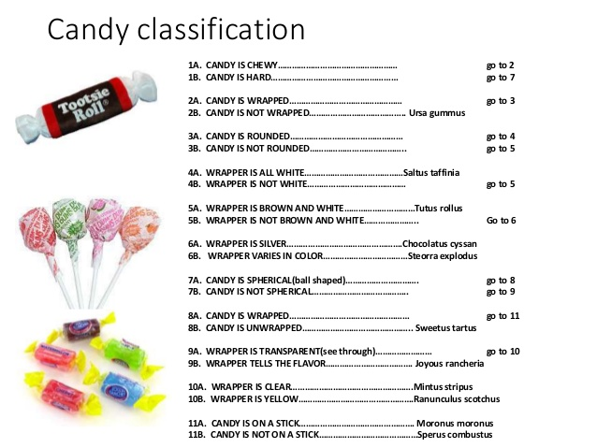
2. Draw a family-tree style diagram that shows how the 6 kingdoms of organisms are related to one another.

