Unit 6 Review Stations/ 3.0

Station 1-Meiosis
- Take a copy of the Amoeba Sisters viewing guide from the station folder.
- Use your device to re-watch the video: The Great Divide-
https://www.youtube.com/watch?v=toWK0fIyFlY
You will need headphones or turn on the closed captioning.
3. As you watch the video, complete the viewing guide worksheet.
4. Use your notes and textbook as additional resources if needed.
5. Paste the worksheet into your notebook.

Station 2-Karyotyping
- Take a copy of the Karyotype Practice sheet from the station folder. Record all answers in your notebook.
- Answer A1 from the sheet. Share answers with your neighbors to make sure you have a complete answer.
- Analyze Karyotypes B-E by answering the questions for each.
- When you have finished, see the teacher for a key! RETURN THE KEY TO THE TEACHER AND THE KARYOTYPES TO THE FOLDER.
- Write two chromosomal abnormalities that are caused by an additional or missing sex chromosome.

Station 3-Non-Mendelian (Co/Inc, Sex, Mult alleles)-Mixed practice
- Take a copy of the Mixed Genetics Practice Problems from the station folder.
(Lassiter HS, "My Blog", 2016)
- Complete the following in your notebook: #1, 3-5, 8-9, 14-15. Make sure you show all Punnett squares and write out required answers.
- When you have finished, bring your answers up to the front and use the key to check your work so you are ready for the test tomorrow!

Station 4-Pedigrees
- Draw and shade in the pedigree based on the following information:

A 20 year old man diagnosed with Muscular Dystrophy, an X-linked recessive gene, has a sister who pregnant. His sister and her husband are healthy and think there is no way she can pass the disease on to their child. They do not know the sex of the unborn baby. If you were a genetic counselor, what would you tell the couple?

2.
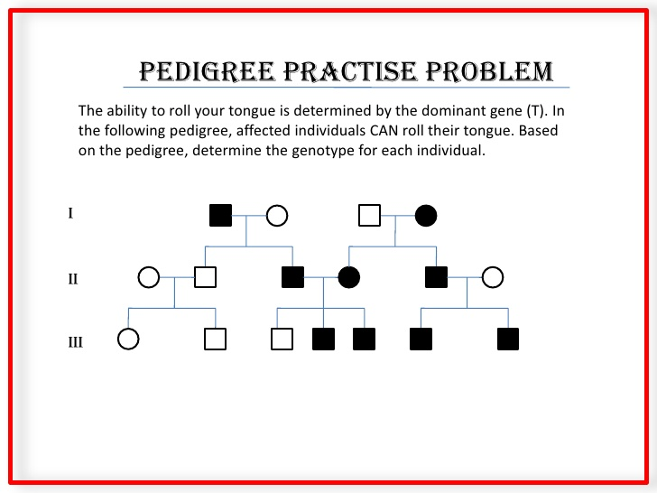

  - How many individuals in this family can roll their tongue?
  - What is the genotype for individual I-a? (remember you can be
heterozygous for a dominant trait but it will be fully shaded on
the pedigree)
  - What is the genotype for individual I-c?

Station 5-Throwback
Create a Feynman Study Sheet for the RELATIONSHIP BETWEEN PHOTOSYNTHESIS AND RESPIRATION. Make sure you focus on the connection between the two processes.

