Station 1: Transport Data

- Pick up the handout of cell transport data and use the “Talk to the Text” strategy to understand the data. Fill in topics for discussion under each graphic.
- Answer the analysis questions for Graphics 2 and 5

Station 2: Cell Organelles - Who am I haikus?

A haiku is a Japanese poem that has three lines. Each line has a specific number of syllables- Five, Seven, Five. Usually haikus are written about something in nature.

Read these Cell Organelle haikus. Try to determine what organelle is described in the haiku. Write the organelle on your review stations sheet.

Haiku A Haiku B
Photosynthesis All eukaryotes
Sunshine to carbohydrates Glucose converts in all cells
Lean, green plant machine ATP for me!
Who am I? Who am I?

Haiku C Haiku D
Rectangle, box, cube Sometimes I float free
It is hip to be a SQUARE Polypeptides made on me
Structure and support See me? Tiny dots
Who am I? Who am I?

Haiku E Haiku G
Homeostasis Write your own Cell Organelle Haiku.
Like the bouncer at a club Read the haiku to your neighbor
Needed bilayer & see if they can name the organelle.
Who am I? Remember the format!

Station 3: ***Throwback*** Station

Biochemical Families: Re-create this chart on your station paper. Complete the information!
Macromolecule | Building Block Molecule (subunit) | Atoms | Uses
Carbohydrate |  |  | Quick Energy
 | Amino Acid
 |  | C,H,O,N, P

Enzymes: Read the experimental design. Using what you know about enzymes, answer the thinking questions on your station sheet. Please use complete sentences.

A biologist prepared three flasks in a lab to test the activity of the enzyme amylase. Amylase breaks down polysaccharides into monosaccharides. The three flasks each contain 5 milliliters of starch in water. The biologist then added amylase to two flasks and water to the third. The experimental set-up is shown in the diagram below:

Add 5 drops of Amylase Add 5 drops of Water Add 5 drops of boiled Amylase
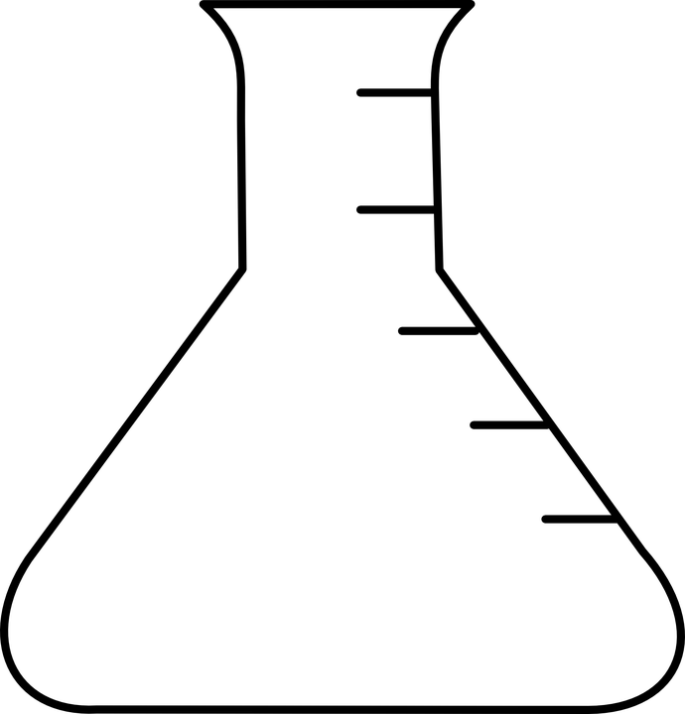
4% Starch in Water 4% Starch in Water 4% Starch in Water
FLASK A FLASK B FLASK C

- pH and temperature can both affect enzyme activity. Which factor is being tested in this lab experiment?
- Amylase breaks down starch into monosaccharides best at room temperature. At the end of the experiment, which flask would have the MOST simple sugars? Explain your answer.
3. If amylase is optimal at room temperature, which flask would have DENATURED
enzyme? Explain your answer.

Station 4: Cell Types
Complete the Prokaryotic coloring and questions.

Station 5: Membrane Structure and Transport
- Review the Feynman technique that you learned in the last unit at https://collegeinfogeek.com/feynman-technique/
- Using the technique and examples, create a review of plasma membrane structure.
- Be sure to show the relationship between the structure of the plasma membrane and its function as it maintains homeostasis for the cell.

