Station 1: Transport Vocabulary

Honors - Use Blue Cards/Academic -Use Yellow Cards

- Take all cards out of the bag. Read through all of the terms and definitions dealing with transport across a cell membrane.

2. You should create a three x three square where each term is paired with the correct
description. Ask the teacher for a key to check yourself.

3. Make notes on your paper of any terms you need to study/review for the test.

4. Write two cellular transport multiple choice style test questions from this material that
you would expect to see on the test. Share with your neighbor and see if they can
answer them correctly. Mark the correct answer.

Station 2: Cell Organelles - Who am I haikus?

A haiku is a Japanese poem that has three lines. Each line has a specific number of syllables- Five, Seven, Five. Usually haikus are written about something in nature.

Read these Cell Organelle haikus. Try to determine what organelle is described in the haiku. Write the organelle on your review stations sheet.

Haiku A Haiku B
Photosynthesis All eukaryotes
Sunshine to carbohydrates Glucose converts in all cells
Lean, green plant machine ATP for me!
Who am I? Who am I?

Haiku C Haiku D
Rectangle, box, cube Sometimes I float free
It is hip to be a SQUARE Polypeptides made on me
Structure and support See me? Tiny dots
Who am I? Who am I?

Haiku E Haiku G
Homeostasis Write your own Cell Organelle Haiku.
Like the bouncer at a club Read the haiku to your neighbor
Needed bilayer & see if they can name the organelle.
Who am I? Remember the format!

Station 3: ***Throwback*** Station

Biochemical Families: Re-create this chart on your station paper. Complete the information!
Macromolecule | Building Block Molecule (subunit) | Atoms | Uses
Carbohydrate |  |  | Quick Energy
 | Amino Acid
 |  | C,H,O,N, P

Enzymes: Read the experimental design. Using what you know about enzymes, answer the thinking questions on your station sheet. Please use complete sentences.

A biologist prepared three flasks in a lab to test the activity of the enzyme amylase. Amylase breaks down polysaccharides into monosaccharides. The three flasks each contain 5 milliliters of starch in water. The biologist then added amylase to two flasks and water to the third. The experimental set-up is shown in the diagram below:

Add 5 drops of Amylase Add 5 drops of Water Add 5 drops of boiled Amylase
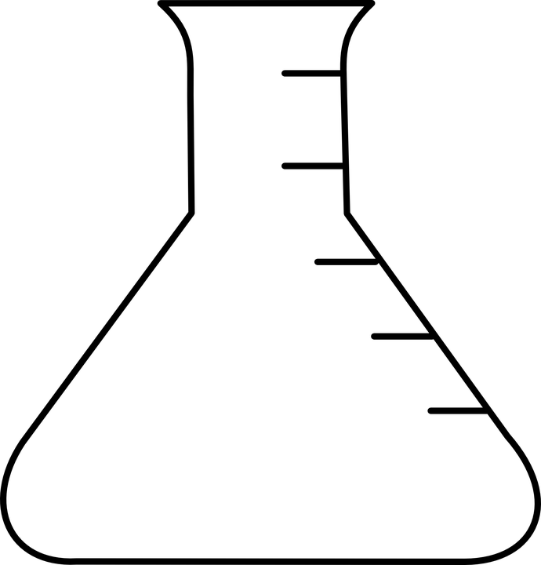
4% Starch in Water 4% Starch in Water 4% Starch in Water
FLASK A FLASK B FLASK C

- pH and temperature can both affect enzyme activity. Which factor is being tested in this lab experiment?
- Amylase breaks down starch into monosaccharides best at room temperature. At the end of the experiment, which flask would have the MOST simple sugars? Explain your answer.
3. If amylase is optimal at room temperature, which flask would have DENATURED
enzyme? Explain your answer.

Station 4: Cell Types
Complete the Prokaryotic coloring and questions.

Station 5: Membrane Structure and Transport
Watch the video at https://youtu.be/Ptmlvtei8hw?list=PLwL0Myd7Dk1F0iQPGrjehze3eDpco1eVz and answer the following:
- How does the cell membrane maintain homeostasis in cells?
- Draw the phospholipid bilayer and label which parts are polar and which parts are non-polar.
- What do all molecules that can pass through the cell membrane via diffusion have in common?
- Add proteins to your diagram. How do proteins help with diffusion?
- How does the structure of the membrane allow for molecules to move? (hint: think “fluid mosaic”)
- For large molecule transport, the membrane acts differently. What does it do? List the two main examples of large molecule transport.

