Tranport Data

Graphic #1
Follow along and Talk to the Text with your teacher.

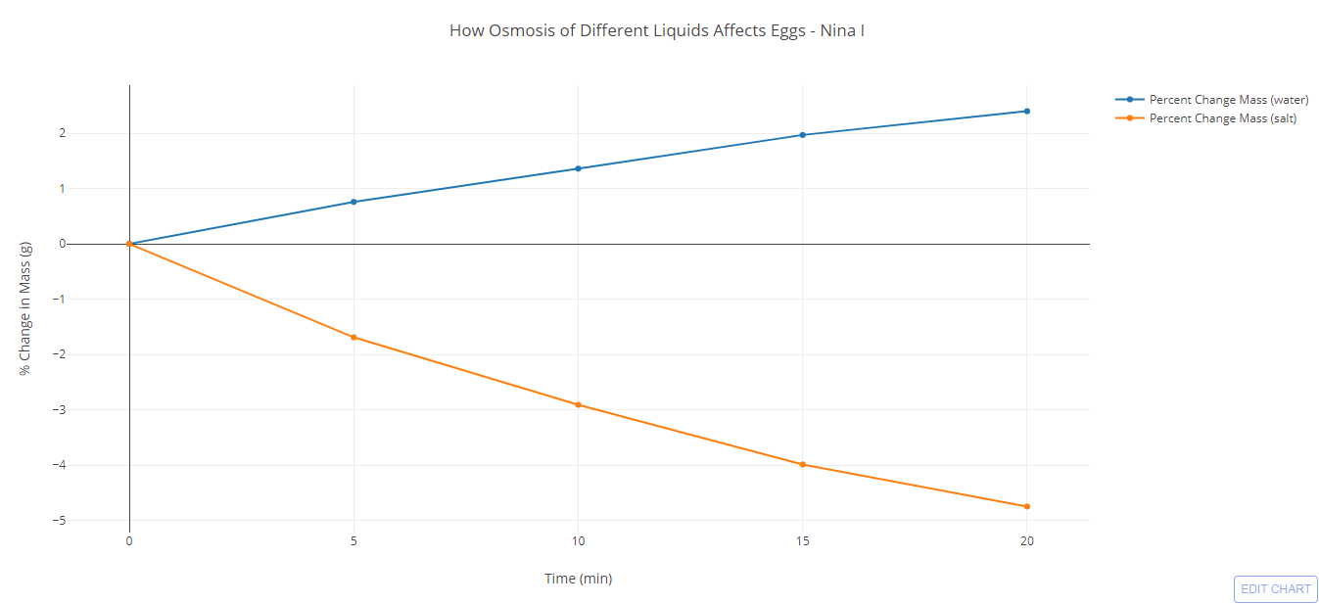

Topics for Discussion:

Graphic #2
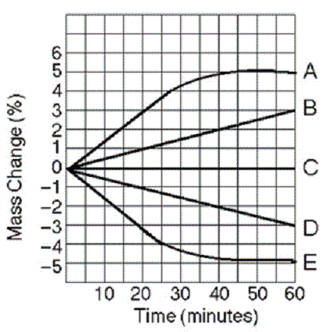

Topics for Discussion:

Graphic #3
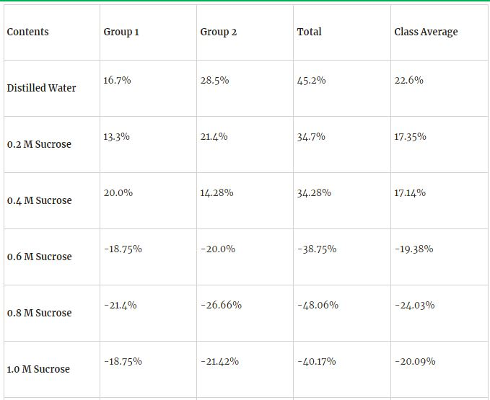

Topics for Discussion:

Graphic #4
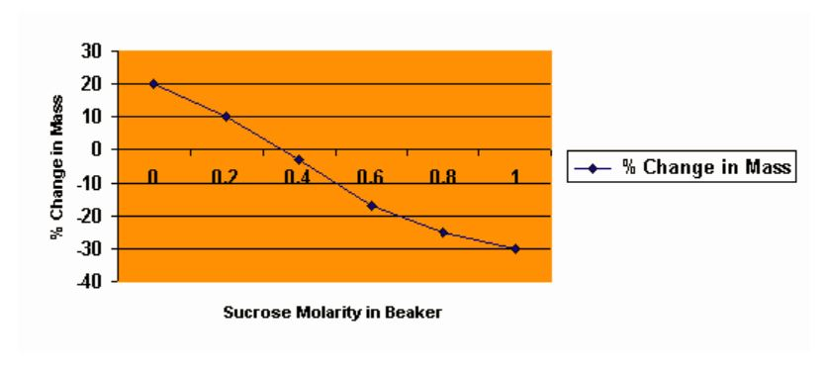

Topics for Discussion:

Graphic #5
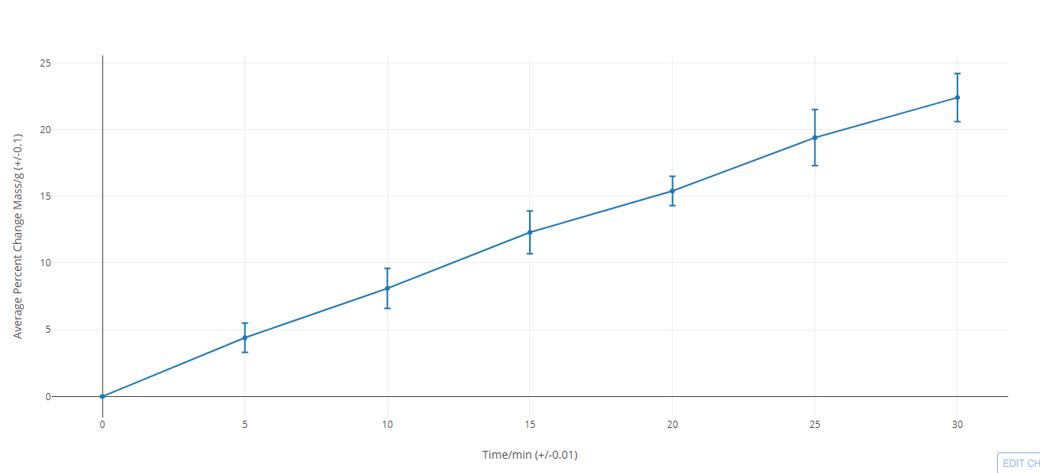

Topics for Discussion:

Analysis Questions:

Graphic #2
Five cells (A-E) of various NaCl concentrations were placed in open beakers containing 0.6 M NaCl solution.
- Which of the cell(s) is hypertonic to the solution in which it is placed?
- Which cell(s) have reached equilibrium according to the graph? How do you know?
- Why have the other cells NOT reached equilibrium?

Graphic #5
The salt concentration inside a potato cell is 0.4 M. A slice of potato was placed in a solution and the mass of the potato was measured at various time intervals. Graph #5 shows the percent change in the mass of the potato slice over time.
Would you describe this solution as being hypotonic, hypertonic, and isotonic? Support your answer with evidence from the graph.

