Radish seed experiment

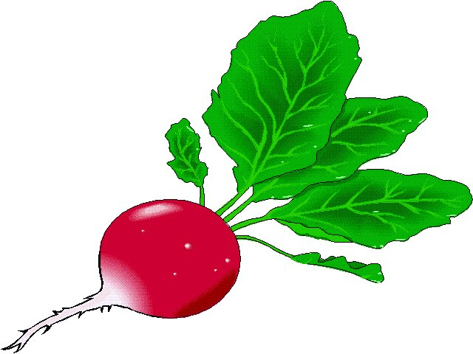

**Objective: To use the scientific method to solve a problem.**

**Problem:** Is light necessary for seed germination?

**Background**: Germinate means the plant inside the seed begins to grow.

Seed stores food for young plant to grow before it can photosynthesize and make its own food.

Seeds need water and correct temperature to grow

**Hypothesis:** Choose a hypothesis…Finish the sentence you think is correct

If seeds need light to germinate then I will notice……..

If seeds DO NOT need light to germinate then I will notice……..

# Experiment-

# 2 people per group.

# Group member 1 sets up the DARK dish, Group member 2 sets up the LIGHT dish

**Materials:**

2 petri dishes, paper towel, grease marker, 40 radish seeds, graduated cylinder, water.

**Procedure:**

dish 1: write on top with grease marker. Include initials, Block and DARK

dish 2: write on top with grease marker. Include initials, Block and LIGHT

Fold and cut paper towel so **4 layers** fit in bottom of dish

Place towels layers in dish bottom

Use graduated cylinder to measure exactly **20 ml of H2O**

**Pour 20 ml** of H2O into dish bottom

Count out **20 radish** seeds and spread out over wet towel in dish

Place cover on dish

Repeat for both dishes

**Place dark dish in cabinet and light dish on cart by window.**

Number of seeds germinated

LIGHT DARK

|  |  |  |  |  |
| --- | --- | --- | --- | --- |
|  | # Germinated | percent | # Germinated | percent |
| Group 24 hr |  |  |  |  |
| Group 48 hr |  |  |  |  |
| Group 72 hr |  |  |  |  |
| Class 24 hr |  |  |  |  |
| Class 48 hr |  |  |  |  |
| Class 72 hr |  |  |  |  |

**Graph your data** : Use Graphing RULES

**Conclusion and Analysis**: Write answers to questions in QUESTION/ANSWER FORMAT. Use a **separate piece paper** or use your word processor.

1. Was the hypothesis supported or not supported? Explain HOW the data supports your statement.
2. List any errors or mistakes made while doing the experiment
3. Describe at least 1 thing you learned.
4. Describe another experiment that could be an extension to the experiment
5. What is the CONTROL for this experiment? How do you know it is the control
6. List at least 5 constants for this experiment. How do you know they’re constants?
7. As a result of this experiment summarize what is necessary for radish seeds to germinate?
8. List the steps of the SCIENTIFIC METHOD and how you used each step in this experiment.