Name(s): ___________________________________________________ Period: ______ Date: ___________________
Photosynthesis & Cell Respiration POGIL
What is the relationship between photosynthesis and cell respiration?
Why?
Photosynthesis and cellular respiration are important cell energy processes. They are connected in ways that are vital for the survival of almost all forms of life on earth. In this activity you will examine the process of photosynthesis and how cellular respiration and photosynthesis are tied together.
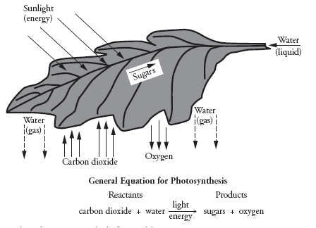
Model 1 – Leaf Sun-Catcher: Leaves help plants capture sunlight so that it can be used to produce food for itself in a process called photosynthesis. Leaves tend to be green in color because they contain chlorophyll which is a green pigment found in chloroplasts. Chloroplasts are organelles found in plants that contain the chlorophyll; this is the structure in which photosynthesis occurs.
- List 3 inputs (things entering) for the leaf in Model 1.
_____________________________________,
_____________________________________,
______________________________________
- List 3 outputs (things leaving) for the leaf in Model 1.
________________________________, _____________________________, _____________________________
- Use the general equation for photosynthesis and Model 1 to answer the following questions.
  - What are the reactants for photosynthesis? _________________________________________________
  - Reactants are also known as: (Circle one) INPUTS OUTPUTS
  - What are the products of photosynthesis? __________________________________________________
  - Products are also known as: (Circle one) INPUTS OUTPUTS
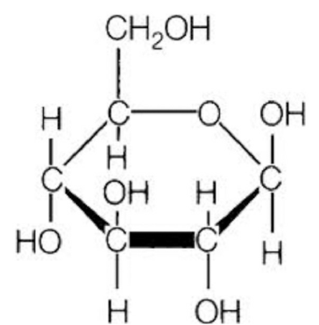
Model 2 – Glucose: Glucose is the sugar that gets produced during the process of photosynthesis; the plant uses this food source to build itself. Most of a plant’s mass will come from the air because that is where it gets the carbon dioxide (CO₂) needed to make glucose. Glucose is also sometimes referred to as “blood sugar”; the glucose in your bloodstream comes from the digestion of the food you eat.
- Count the number of Carbon (C) atoms in a molecule of glucose. _____________
- Count the number of Hydrogen (H) atoms in a molecule of glucose. ___________
- Count the number of Oxygen (O) atoms in a molecule of glucose. _____________
- Complete this chemical formula for glucose, fill in the blanks with the correct numbers that you counted in #4, #5, and #6. C ___ H ___ O ___
- Where does the carbon used to make glucose come from? ___________________________________________
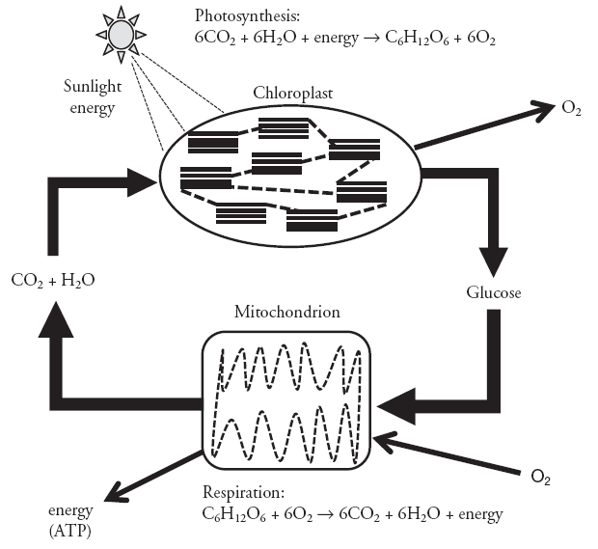
Model 3 – Comparison of Photosynthesis and Cell Respiration: Photosynthesis and cell respiration are processes that depend on one another, each making products that get used by the other. Only plant cells carry out photosynthesis. All cells carry out cell respiration.
- In what organelle does photosynthesis occur?
____________________________________
- What are the 3 reactants needed for photosynthesis?
____________________________________
- What are the 2 products of photosynthesis?
___________________________________,
____________________________________
- In what organelle does cellular respiration occur?
____________________________________
- What are the 2 reactants needed for cellular respiration?
___________________________________,
____________________________________
- What are the 3 products of cellular respiration?
_______________________________, ________________________________, ___________________________
- What 2 products made during cell respiration gets used in photosynthesis?
________________________________________, _____________________________________
- What 2 products made during photosynthesis gets used in cell respiration?
________________________________________, _____________________________________
- Are chloroplasts found in plant cells? Explain your answer. ___________________________________________
___________________________________________________________________________________________
- Are chloroplasts found in animal cells? Explain your answer. _________________________________________
___________________________________________________________________________________________
- Are mitochondria found in plant cells? Explain your answer. __________________________________________
___________________________________________________________________________________________
- Are mitochondria found in animal cells? Explain your answer. ________________________________________
___________________________________________________________________________________________
- As a group, carefully consider and discuss the following statement: Plants can survive on their own because they make their own food. Animals can’t survive on their own but need plants for survival. __________
____________________________________________________________________________________________________________________________________________________________________________________________________________________________________________________________________________________________________________________________________________________________________________

