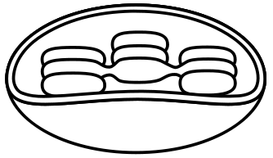

____________ located in the_____________

traps light energy and makes food.

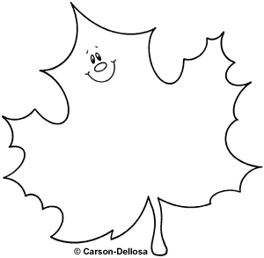

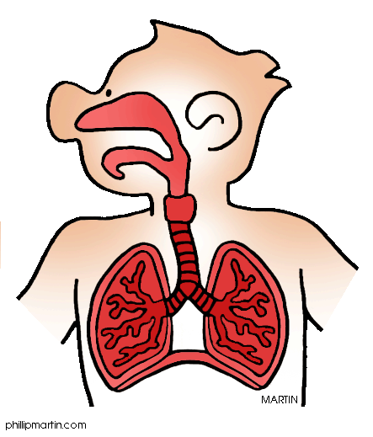[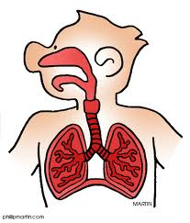](http://www.google.com/imgres?imgurl=http://humanbody.phillipmartin.info/science_respiratory_system.gif&imgrefurl=http://humanbody.phillipmartin.info/respiratory_system.htm&usg=__sTziTM4OgbsbP3JJS_MqG3xxJIw=&h=519&w=443&sz=42&hl=en&start=0&zoom=1&tbnid=-o3xJYR6ouAsMM:&tbnh=161&tbnw=137&prev=/images?q=respiratory+system+clip+art&um=1&hl=en&rls=com.microsoft:en-us:IE-SearchBox&rlz=1I7ADRA_en&biw=1259&bih=811&tbs=isch:1&um=1&itbs=1&iact=hc&vpx=690&vpy=236&dur=10&hovh=243&hovw=207&tx=105&ty=138&ei=VS2iTLaKC8KqlAe-35iOAw&oei=VS2iTLaKC8KqlAe-35iOAw&esq=1&page=1&ndsp=26&ved=1t:429,r:10,s:0)

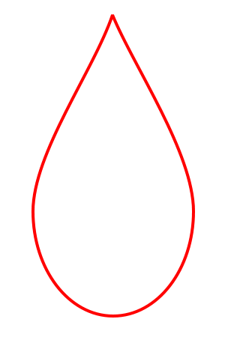

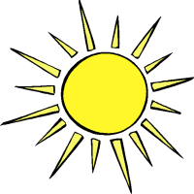

Photosynthesis