Photolab Activity
On a laptop, open http://www.kscience.co.uk/animations/photolab.swf
You will measure the rate of photosynthesis by counting the number of bubbles produced by the cut end of the plant.
Background question: What gas is in the bubbles?
Activity 1: Light Intensity and Photosynthesis
- Slide the light intensity bar to 25 and press the green button on the timer. Count the number of bubbles produced in 1 minute. _________
- Slide the light intensity bar to 50 and reset the timer by pressing the green button on the timer. Count the number of bubbles produced in 1 minute. _______
- The graph below represents a data set collected by scientists studying photosynthesis and light intensity:
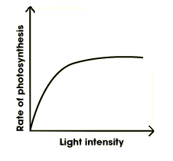
- Compare this data to your results. Do your results confirm what the scientists discovered?
- Why does the graph eventually reach equilibrium?
Activity 2: Amount of Carbon Dioxide and Photosynthesis
- Slide the light intensity to 50 and click on the CO2 bottle once to increase the amount of carbon dioxide by half. Reset the timer and count the number of bubbles produced in 1 minute. ______
- Compare this result to those of #2 in Activity 1.
- Click on the CO2 bottle once more to increase the amount of carbon dioxide to its maximum. Reset the timer and count the number of bubbles produced in 1 minute. _______
- The following graph represents a data set on carbon dioxide concentration and light intensity:
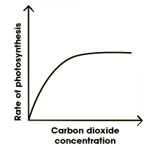
  - Compare your results to the graph. Do your results confirm the results of this graph?
  - Why does this graph reach equilibrium?
Activity 3: Temperature and Photosynthesis
- Set the Carbon Dioxide to its maximum and the light intensity to 50. Click the thermometer once to change the temperature from 10 degrees to 25 degrees. Using the timer, count the number of bubbles produced in one minute. _______
- Now, change the temperature to 40 degrees and count the number of bubbles produced in one minute. _______
- Below is a graph of data collected by scientists on temperature and photosynthesis:
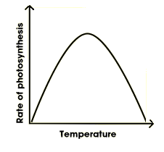
- Compare your results to the graph above. Do your results confirm the information on the graph?
- What is the reason for the shape of this graph? Why is it different from the shapes of the other two above?

