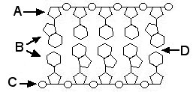

Using the diagram above, fill out the following labels:
- ____________________
- ____________________
- ____________________
- ____________________
What are two differences between a DNA and RNA nucleotide?

What are two differences between a DNA and RNA molecule?

What are the three parts of a nucleotide (in order!)?

What are the building blocks of nucleic acids called?

What is the complementary base pairing rule for DNA? How is the rule different for RNA?

What two things are in the backbone of a nucleic acid?

Color and label the diagram below. Use internet resources to help you with the chemical structures:
