Human Impact Activities
Part I: Invading species
Watch the video clip at http://www.cbsnews.com/video/watch/?id=7386464n and answer the following in your notes:
- What is an invading species? Why are they bad for ecosystems?
- How does a species invade?
- What are some invading species in NC?
- What can be done about invading species?
Part II: Climate Change
Go to http://www.epa.gov/climatechange/kids/ and watch the intro video. Answer the following questions in your notes:
- Describe the greenhouse effect. What traps heat? (the animation under “Learn the Basics” will help you)
- Do we need the greenhouse effect? Why or why not?
- What is the current problem with carbon in the atmosphere? (The video on Carbon under “learn the basics”today’s climate changeAll about carbon will help you)
- Besides carbon, what other greenhouse gasses are there?
- List the effects of global warming on the organisms and ecosystems.
- Finally, go to “Think like a scientist”the Clues of climate change. List the 11 signs of climate change in the picture.
Part III: Acid Rain Station
Look at the graphics below and answer the following in your notes: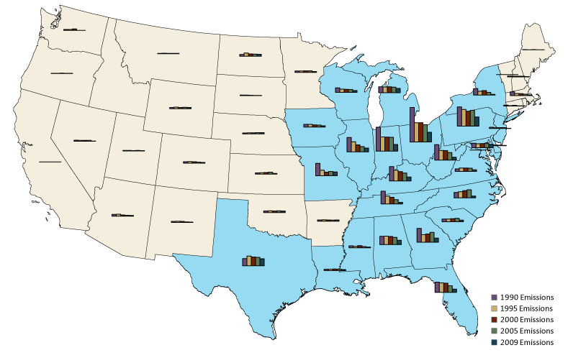
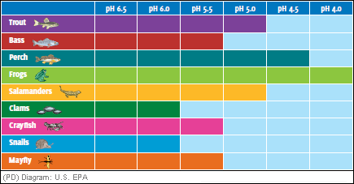
- Draw the pH scale and label the acids and bases.
- What causes acid rain?
- What can humans do to reduce acid rain?
- What explains the difference between the East and West coast rain pH? Look at the map of the United States. The bar graphs show the amount of acid rain over several years.
- What year did NC have the highest acid rain levels?
- What part of the country has the most acid precipitation in general? Make a hypothesis why you think there is a difference in parts of the country. *remember what leads to acid rain*
- Look at the chart above. This chart shows the range of pH that aquatic animals can tolerate.
- What is the pH tolerance range for snails? Frogs?
- The average rainfall that is accumulating in lakes and rivers of NC has a pH of 4.5. Based on this data what animals would survive best in our waterways?

Part IV: Beach Erosion
Watch the video clip at http://www.wwaytv3.com/2012/12/03/dunes-fort-caswell-disappearing. Also, read the article at http://www.nccoast.com/entertainment/waterfront/retired-christmas-trees-assist-beach-erosion-efforts/article_86bd87e6-2685-11e1-9a0b-001871e3ce6c.html and http://www.digtriad.com/news/local/article/251850/57/McCrory--Daltons-Take-On-Restoring-NC-Beaches
- What’s causing the erosion of the dunes?
- Why are the dunes important to the ecosystem?
- What can be done to combat beach erosion?
- Define beach nourishment. Will it work?
Part V: Cause and Effect Concept Map
Fill out the cause and effect concept map from the overhead to analyze the different causes of habitat destruction.

