Genetics Test Remediation
- Green wings are dominant to yellow wings in butterflies. Draw a Punnett square for a heterozygous green butterfly and a yellow butterfly.

- Write the genotypic ratio for the Punnett square in #1: _____ GG: _____Gg:_____gg
- Write the phenotypic ratio for the Punnett square in #1: _____green:_____yellow
- Hemophilia is an X linked recessive disorder. Write the genotype of a healthy male ______.
Write the genotype of a female who carries the trait ________. What are the chances their offspring will have hemophilia?

- For each of the following traits: dominant or recessive / autosomal or X linked / one characteristic or symptom. (use your homework OR genetic disorder project)
  - PKU
  - Sickle Cell Anemia
  - Huntingtons
  - Colorblindness
  - Hemophilia

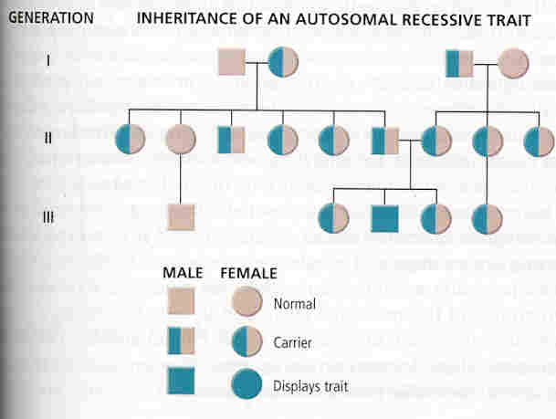
- Define Pedigree. Circle a male who carries the trait. Circle a female who is unaffected.

- Define Karyotype. Define nondisjuntion. Name two chromosome abnormalities that can be formed from nondisjunction and viewed on a karyotype.

