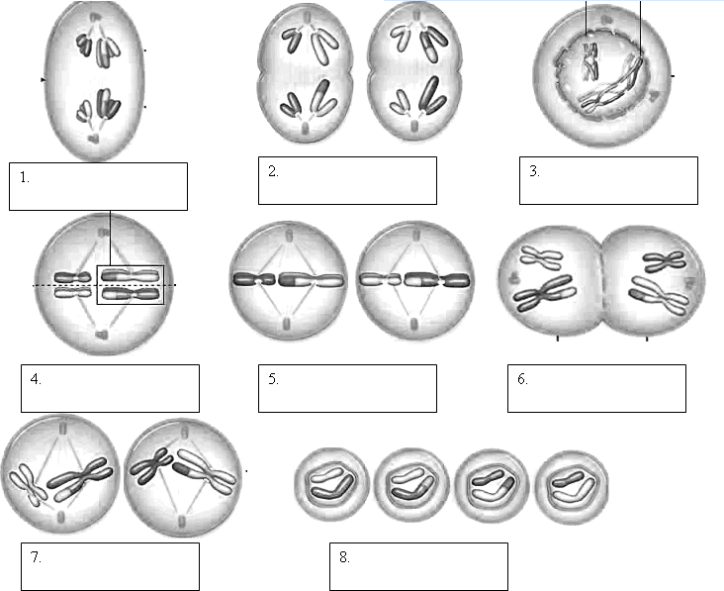
Name the phases of each:

- Homologous Chromosomes pair up and form tetrad
- Spindle fibers move homologous chromosomes to opposite sides
- Nuclear membrane reforms, cytoplasm divides, 4 daughter cells formed
- Chromosomes line up along equator, not in homologous pairs
- Crossing over occurs
- Chromatids separate
- Homologs line up along equator
- Cytoplasm divides, 2 daughter cells formed

- Compare/contrast genotype vs phenotype

- Compare/Contrast codominance vs Incomplete dominance
- For each of the following determine if mode of inheritance is either codominance or incomplete dominance. Determine alleles for each:
Birds can be blue, white, or white with blue-tipped feathers.
Flowers can be white, pink, or red.
A Hoo can have curly hair, spiked hair, or a mix of both curly and spiked.
A Bleexo can be spotted, black, or white.
Punnett Square Practice
Tall plants (T) are dominant to short plants (t). A heterozygous tall plant is crossed with a homozygous short plant. Set up a punnett square and provide phenotypic and genotypic ratios.
Alice has type A blood and her husband Mark has type B blood. Their first child, Amanda, has type O blood. Their second child, Alex has type AB blood.
What is Alice’s genotype? _____________
What is Mark’s genotype? _____________
A black chicken and a white chicken are crossed. What is the probability that they will have erminette chicks?

