Part 1
Gel Electrophoresis Lab
Go to http://learn.genetics.utah.edu/content/labs/gel/
- List the materials needed to make a gel
- Explain how you made the gel
- Explain how you set up the apparatus for the gel
- What does the buffer do?
- How was the DNA loaded into the gel? (list the steps that were taken)
- What kind of charge does DNA have? How does this affect how it moves through the gel?
- Draw a picture of what your gel looked like after the current was applied and the gel was stained. Label the short DNA strands and Long DNA strands.
- Why do short and long strands move at different rates in the gel?
Part 2
Go to Link: http://www.teachersdomain.org/asset/tdc02_int_creatednafp2/
1. Who committed the crime?
2. What additional steps were taken in this procedure to preserve the DNA fingerprint?
3. In what other way is a DNA fingerprint used?
4. Look at the gel pictured below and identify the father of the child.

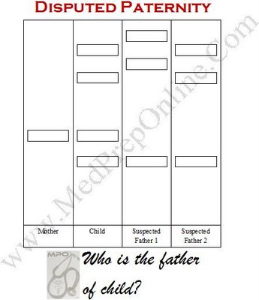
4. How is reading a crime scene DNA fingerprint different from reading a DNA fingerprint for paternity testing?

