Gel Electrophoresis Activities / Interactions and Heredity
Classwork 15 pts.

Part A: Pearson Lab Bench
http://www.phschool.com/science/biology_place/labbench/lab6/concepts2.html

- Work through the tutorial on Gel Electrophoresis. Read all information, run animations, make notes. Notes should focus on:
- What are restriction enzymes and how do they work?
- What are the steps in a general gel electrophoresis procedure?
- What is the purpose of a ‘marker’ and a standard curve?
- Hind III is a restriction enzyme that is commonly used to cut DNA into marker fragments. How many bands does Hind III cut from the DNA sample?
- Complete the two practice problems.
- Take the 8 question quiz at the end. Record your score _______________.

Part B: Observing the apparatus and loading gels.

- Take pictures of or diagram the set up of the gel electrophoresis apparatus at each stage.
- Practice loading 10 ul of sample into the wells.
- 1000ul = 1ml . Use this information to perform the following conversions for micropipette use.

200 ml = ______________ul

1.5 ul = _______________ml

1.5 ml =_____________ul

.76 ml =_____________ul

Part C: Reading Gels for Application

- This is a DNA fingerprint exhibiting samples from a victim, two suspects, and the crime scene. Which of these DNA fragments is common to both the victim and Suspect 1?
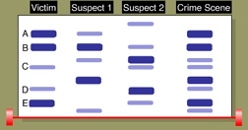

- Under each column in the autoradiograph, write the letters associated with each individual's genotype. For example, the genotype of the mother in the first column is A/D. Then, circle the letter in the child's genotype that represents the gene inherited from the mother.
Which "letters" must the child have inherited from its father?
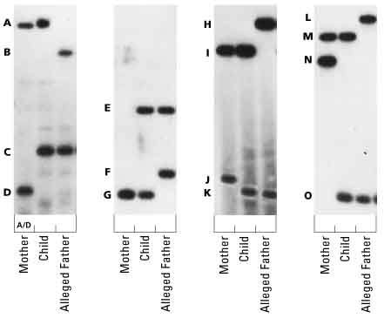

- Use the following DNA fingerprint to answer the questions:
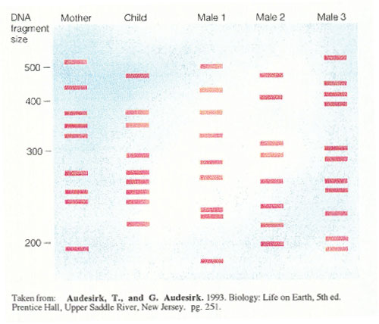

- Which male is the father of the child?
- Give the approximate base pair size of the bands the child received from the mother.
- Give the approximate base pair size of the bands the child received from the father.
- Is every band in the child’s fingerprint accounted for?

- Brainstorm ways you could use gel electrophoresis technology for evolutionary research.

