You are what you eat: Food Label Analysis

Pt. 1 Introduction
When you go to a gas station you have a choice of which fuel to choose for your
car: regular, super unleaded, or premium. When you go the grocery, restaurant, or
cafeteria you have a choice of which fuel to choose for your body. Different fuels
(food s) contain different amounts of energy (calories). There are also different kinds of
energy. The two main types of food energy are carbohydrates and fats.
Carbohydrates have 4 calories per gram and fat has 9 calories per gram.
On the average Americans eat a diet which is too high in fat. The Dietary Guidelines
suggest that 55% of a person’s calories should come from carbohydrates and less than 30% from fat. A small amount of energy is from protein.

Does all of this sound confusing? Well, under a Federal law passed in 1990 almost all
packaged foods must have nutrition labels. The information on these labels can help
you make healthful food choices. Let’s take a look.

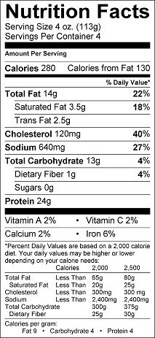
1. Circle the number of calories found in one serving on the food label.
2. How many of those calories come from fat.
3. Shade in yellow the amount of salt found in one serving of this food.
4. Shade in red the different types of fat found in one serving of this food.

You are what you eat: Food Label Analysis

Pt. 1 Introduction
When you go to a gas station you have a choice of which fuel to choose for your
car: regular, super unleaded, or premium. When you go the grocery, restaurant, or
cafeteria you have a choice of which fuel to choose for your body. Different fuels
(food s) contain different amounts of energy (calories). There are also different kinds of
energy. The two main types of food energy are carbohydrates and fats.
Carbohydrates have 4 calories per gram and fat has 9 calories per gram.
On the average Americans eat a diet which is too high in fat. The Dietary Guidelines
suggest that 55% of a person’s calories should come from carbohydrates and less than 30% from fat. A small amount of energy is from protein.

Does all of this sound confusing? Well, under a Federal law passed in 1990 almost all
packaged foods must have nutrition labels. The information on these labels can help
you make healthful food choices. Let’s take a look.

1. Circle the number of calories found in one serving on the food label.
2. How many of those calories come from fat.
3. Shade in yellow the amount of salt found in one serving of this food.
4. Shade in red the different types of fat found in one serving of this food.

