Evolution and Behavior Remediation
Helpful terms for #1-11: Darwin adaptation cladogram vestigial organ
Convergent evolution Divergent evolution coevolution behavioral isolation
punctuated equilibrium phylogenic tree geographic isolation homologous structures
- ____________ Any structure, behavior or process that makes an organism better suited for survival. Give two examples:
- ___________ Father of Evolution
- ___________ When two species evolve and become more dissimilar
- __________ Chart used to show evolutionary history and ancestor relationships
- __________ Structures in different species that have the same appearance and provide evidence that the species shared a common ancestor.
- ___________ When a species suddenly appears or disappears due to a catastrophic event or natural phenomenon.
- ___________ When two species are evolving and getting more alike
- ___________ A remnant of a body structure that no longer has a purposeful use.
- ___________Two species that share a relationship evolve with each other. Example: Flowers and pollinators.
- ___________ Separating groups by physical features such as a river to eventually form two species.
- ___________Separating groups by behaviors such as mating rituals to eventually form two species.
- What evidence did Darwin use to show that organisms may have shared a common ancestor? (at least 3)

- True/False: Darwin used DNA and amino acid evidence to determine evolutionary relationships.

Use the Cladogram and Data to answer the following questions #24-26: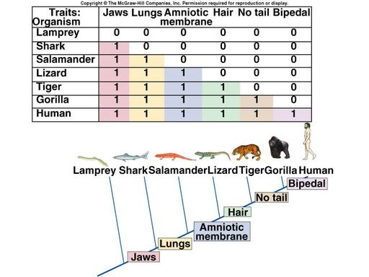
- What group of animals has the most characteristics according to the data table? Where is that organism located on the cladogram?

- What two organisms are the most similar according to the data and cladogram? Explain your answer.

- Name all of the organisms according to the cladogram who use lungs to breathe.
17-19.:
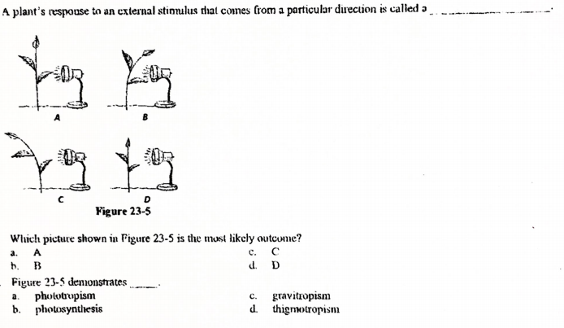
Use the following terms for questions 20-28 :
Tropism Nastic Movement Instinct Learned behavior
Classical conditioning Openant Conditioning Pheromone Imprinting Habituation
Taxis Reflex

20 _____________________________ Ivan Pavlov’s discovery that he could train his dogs to have a natural response to an unnatural stimulus.
21. _____________________________ Trial-and-Error learning, like a rat running through a maze.
22. _____________________________ Organisms getting used to an unimportant stimulus, so that they eventually ignore it. Give an example:

23. _____________________________ Konrad Lorenz’s discovery that animals will act like the adult that cares for them during a critical early period in their development. Why is Tarzan NOT a good example of this?

24. _____________________________ Growth of a plant toward or away from a stimulus. Which is positive, toward or away?

25. ____________________________ Movement of a plant toward or away from a stimulus. The movement is reversible.
26. ____________________________ A behavior that an organism can exhibit from birth/hatching without being taught. Give an example:

25. ____________________________ A behavior that is picked up or modified by experience. Give an example:

26. ____________________________ General term for response to a stimulus. Give an example:

27. ____________________________ A chemical that an organism emits to communicate with other organisms.
28. ____________________________ A quick response to a stimulus that the organism cannot think about or control. Give an example:

29. What is the role of plant hormones in tropism? Use an example in your explanation.

30. Describe what a honey bee dance is and what it’s used for.

