Unit 5: DNA, Protein Synthesis and DNA Technology
Unit 5 References: Textbook Ch. 11 & 13, DNA Protein synthesis playlist at http://www.hippocampus.org/Biology?user=ahawley
Quiz Dates: _____________________Test Date: _______________________

A: Nucleic Acid Structure
1. Using the references listed above, define the following terms in your own words
a. DNA
b. RNA
c. Nitrogenous Base
d. Double helix
e. Hydrogen bond
f. Phosphate
g. Pentose sugar
h. Nucleotide
2. Fill in the following Venn Diagram to compare and contrast DNA and RNA:
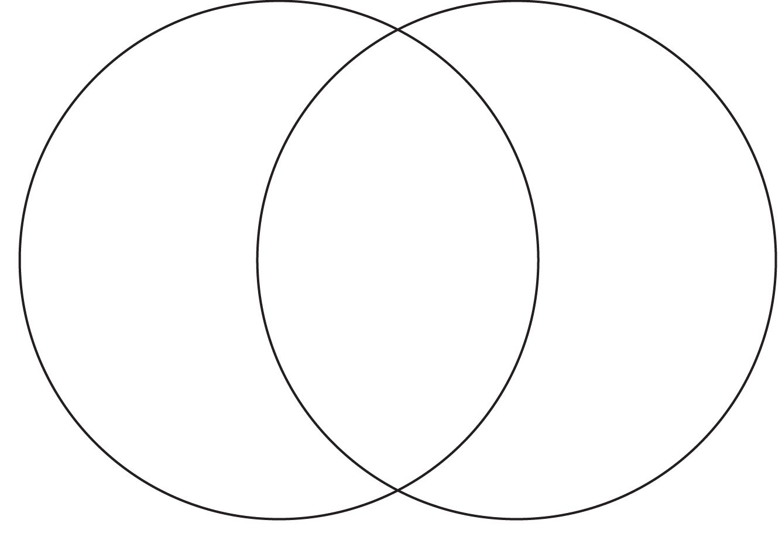
RNA
DNA
3. List the 4 Nitrogenous bases in DNA and state the complimentary base pairing rule:
a. __________________________ which is abbreviated __
b. __________________________ which is abbreviated __
c. __________________________ which is abbreviated __
d __________________________ which is abbreviated __
The complimentary base pairing rule states that ___ always bonds with ___ and ___ always bonds with ___ in DNA. It's the same with RNA except that the base __________ replaces ___________ so that ___ bonds with ___.
4. Which are stronger, hydrogen bonds or covalent bonds? ______________________________
5. Draw a DNA nucleotide in the space below and identify where covalent bonds are and where a hydrogen bond would form:

B: Replication
1. In your own words using less than 5 words, define Replication.
Replication is a process that's not part of DNA's everyday function. Instead, it's only used in preparation for 1 important cell process that we've learned about. What is that process? ______ ________________
2. Play the simulation of Replication in the VLAB on Replication at: https://www.sascurriculumpathways.com/portal/Launch?id=5. Make sure that you do not turn on the replication machinery! Note: you will need to log in to see the resources! Create an account and use the following class code: umd7vh96 in the sign-up field.
Sketch and describe a replication fork. Why is "fork" an appropriate name?

3. What biochemicals support the process of replication by doing things like untwisting/re-twisting DNA, positioning new nucleotides, proofreading the new strand, etc?

4. Replication is said to be a semi-conservative process. What does that mean? (Hint: think about what it means to conserve something. What's being conserved during replication?)

5. Once DNA is replicated, does it stay in the nucleus or leave? Why?
C. Protein Synthesis
1. In your own words using less than 7 words, define transcription.
2. Fill out the Venn diagram below to compare and contrast replication and transcription:
Transcription
Replication
3. In your own words using less than 7 words, define Translation
4. Protein Synthesis is a two-step process. To see the steps, work through the simulation at: https://learn.genetics.utah.edu/content/basics/transcribe/
Once you've seen the steps, fill in the chart below for these steps:
Step of Protein Synthesis | Nucleic Acid(s) Involvved | Location of the Step (in the cell) | Product (s) of the Step | The Point of Taking the Step
1. Transcription
2. Translation
5. Define the following terms in your own words:
a. Codon
b. Anticodon
c. mRNA
d. tRNA
e. rRNA
f. Mutation
D. DNA Technology
1.Define the following terms in your own words:
a. restriction enzyme
b. plasmid
c. genetic engineering
d. transgenic organism
e. genome
2. We'll go over how Gel electrophoresis works in class. However, you should do some internet research to find the 3 uses of gel electrophoresis in biotechnology:
a.
b.
c.
3. Watch the first 10:35 minutes of the video at https://www.youtube.com/watch?v=5vKa7ph89OM&list=PLQXTnDJxrt7aOIdcCExo3OqTze9i3cKWJ&index=8 and answer the following:
a. what is recombinant DNA?
b. List and describe the uses of recombinant DNA technology:

4. Watch the video at: https://animoto.com/play/0aitkUH3lLuvxpA1gGKqoA
a. What is the connection between cloning and stem cells?
b. Fill out the chart below
Type of Cloning | Natural or Done in a Lab? | Purpose?

5. Watch the video at https://animoto.com/play/mwIgOx9VdgJnyXyP0WQXcA and describe the connection between the HGP and gene therapy.

