Unit 3: Cells pt.1
Unit 3 References: Textbook Ch. 6, 7, 8
Quiz Dates: _____________________ Test Date: _______________________

A: Endosymbiont Theory
- List the three points of the Modern Cell Theory

- Once prokaryotic cells were present on Earth, larger more complex cells began to form. The description of this process is known as the Endosymbiont Theory. Describe the theory in YOUR OWN WORDS after viewing the video clip: https://www.youtube.com/watch?v=bBjD4A7R2xU .

B: Types of Cells
- Complete the venn diagram to compare and contrast prokaryotic cells and eukaryotic cells. Include at least two differences for each type of cell, an example of each and at least three similarities.
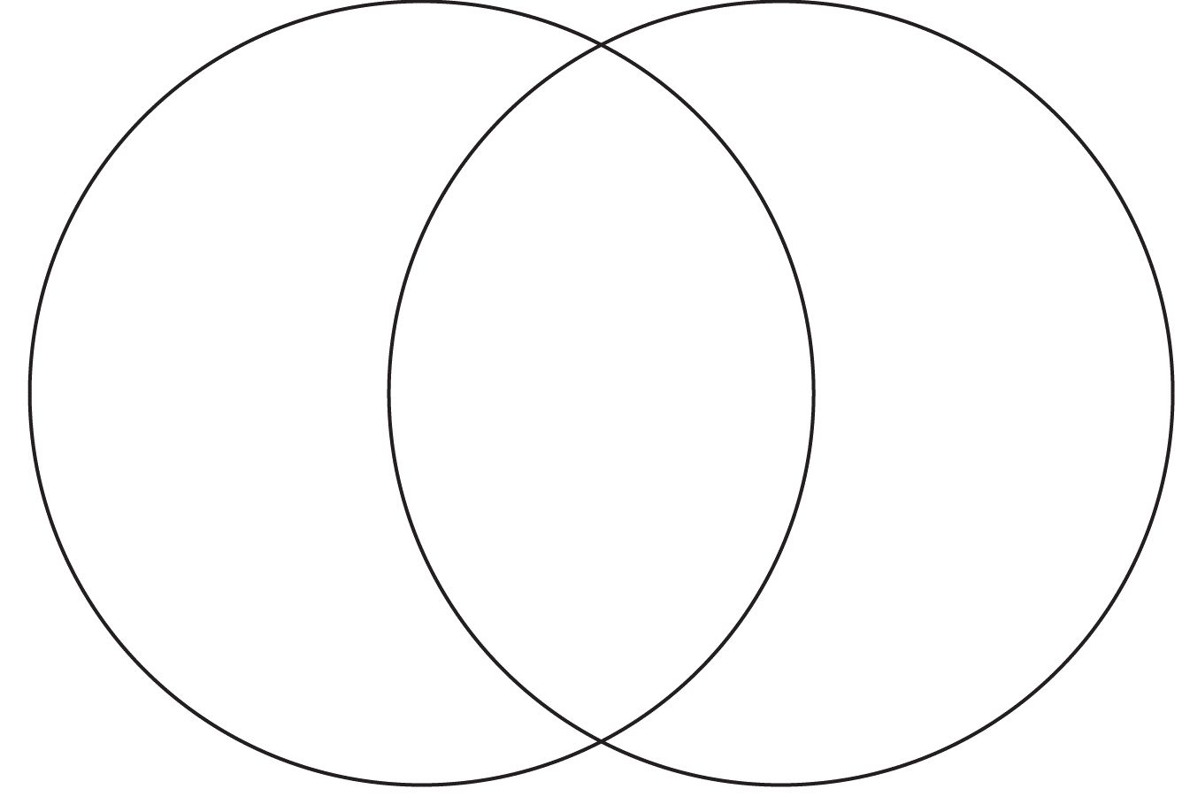
Prokaryotic
Eukaryotic

- Watch these video clips: https://www.youtube.com/watch?v=MfopLilIOeA AND
http://www.nextvista.org/cells-magnified/ Make notes as needed.
- Place the following in order from smallest to largest: cell, organ system, tissue, organelle, organ.
- Define organelle in your own words. Give the function of the following cell organelles. The written function should be no more than 4 words!
- Ribosomes
- Nucleus
- Chloroplasts
- Mitochondria
- Cytoplasm
- Cell Membrane
Circle the structures that are found in prokaryotic cells.
C: Transport
across the Cell (plasma) Membrane
- Define the following terms in YOUR OWN WORDS.
  - Selectively Permeable
  - Concentration Gradient
  - Homeostasis
  - Dynamic Equilibrium

- Write a paragraph that describes the plasma membrane of a cell. Make sure your paragraph includes the structure AND the function of the membrane. Your paragraph must use and describe the vocabulary terms from #1 (a-d).

- Complete this chart:
Types of Transport | Use of Energy?  (y/n) | Concentration Gradient Movement?  (with / against) | Use a membrane protein?  (y/n) | Type of material transported?
Osmosis
Diffusion
Facilitated Diffusion
Active Transport
Resource if your textbook is not helpful: https://www.youtube.com/watch?v=kfy92hdaAH0

D: Cell Transport Applications
- Go to the website: https://www.abpischools.org.uk/topic/homeostasis-kidneys/4
Read “Why water balance matters” and watch the two animations.

- Use arrows to show how WATER will move in the two scenarios below:

Environment - 70% water Environment – 20% sugar solution

Cell – 10% sugar solution
Cell -70%water

- If a red blood cell is placed into a test tube of salt water, what will happen to the cell? Is this solution hypertonic, hypotonic, isotonic?

Scientists discover Critter X. They know it is an aquatic animal and can live in water but they are not sure if it lives in salt water or fresh water. When they place Critter X in distilled water the cells and tissues swell up and begin to rupture. What is happening and what does it tell scientists about the natural habitat of Critter X?

- Plants have to use water and their cell structures to create shape and structure in the overall organism. When plants become dehydrated they wilt. They need water to create turgor pressure.
  - Define Turgor Pressure.
  - Explain how a plant cell’s central vacuole and cell wall help make the cell rigid.

