Biology EOC Review

Fall 2012

**Essential Standard 1**

1. Define:
2. Selectively permeable membrane
3. Diffusion
4. Dynamic equilibrium,
5. Osmosis
6. Chromatin:
7. Chromosome:
8. Sister chromatids:
9. Centromere
10. Sexual reproduction
11. Asexual reproduction
12. Somatic cell
13. Chemotaxis
14. Phototaxis
15. Stimulus
16. Gametes
17. Zygote
18. Fertilization
19. Crossing over
20. Name 3 differences between plants and animal cells.
21. *Cell wall is rigid and provides support while the cell membrane is fluid-like.*
22. Organelle structure and function:
23. Vacuole
24. Nucleus
25. Chloroplast
26. Mitochondria
27. Plasma membrane
28. Cell wall
29. Ribosomes
30. Cytoplasm
31. *Hierarchy of cell organization: cell 🡪 tissues 🡪 organs 🡪 organ system*
32. *Increased surface area (aid in increased cellular functions) – mitochondria (increased energy production), inner-lining of digestive tract (absorption), respiratory surfaces (Oxygen absorption)*
33. Prokaryotic vs. Eukaryotic cells – label each as prokaryotic or eukaryotic
34. Has nucleus
35. Membrane bound organelles
36. Bacteria
37. Protist, fungus, plants, and animals
38. Has only cell wall, cell membrane, and ribosomes
39. What are the differences between plant and animal cells?
40. Cell specialization: Type of cells – structure relate to function
41. Red blood cell --
42. Nerve Cell –
43. Plant cell in saltwater – the vacuole will _______ water.  
    Ex. Putting a freshwater plant into saltwater.
44. What happens to a cell if placed into freshwater (100% water)? _______________________
45. A paramecium is a freshwater organism that continually gains water, it has a contract vacuole that pumps water out which helps it maintain ______________ (water balance).
46. Name 3 characteristics of Active Transport.
47. If a cell contains 10% sugar, which of the following solutions would cause the **greatest amount** of water gain ____ and which would cause the greatest amount of water loss? ____
48. 1%sugar solution
49. 5 % sugar solution
50. 10 % sugar solution
51. 15 % sugar solution
52. 20 % sugar solution
53. What is the difference between active and passive transport?
54. What is the source of energy for cell processes such as active transport?
55. Why do we describe the cell membrane as semipermeable or selectively permeable?
56. What is a diploid cell?
57. What is a haploid cell?
58. Compare mitosis and meiosis:
    1. Which division produces haploid cells?
    2. Which division produces diploid cells?
    3. Which includes the replication and division of DNA?
    4. Which division includes crossing over?
    5. Which division produces the gametes?
    6. Which has only one cell division?
    7. Which has two cells divisions?
    8. Which produces two cells?
    9. Which produces four cells?
    10. Which division produces cells that are different from the parent cell?
    11. Which division produces cells that are identical to the parent cell?
    12. Which division involves independent assortment?
    13. Which is part of sexual reproduction?
    14. Which is a type of asexual reproduction?
59. What is crossing over?  What is the value of crossing over?
60. What is independent assortment?  What is the value of independent assortment?
61. 3 reasons cells are limited to a small size.
62. Mitosis is a part of (sexual / asexual) reproduction.
63. Meiosis is a part of (sexual / asexual) reproduction.
64. Mitosis is the division of ____ ______ cells.
65. Meiosis produces ________ (type of cell)
66. What are some advantages of sexual reproduction:
67. What are some advantages of asexual reproduction?
68. How many chromosomes do our body cells have?   
     Sex cells (gametes)?
69. *Gamete 🡪 zygotes 🡪 embryo*
70. *Be able to put mitosis diagrams in order and describe what is occurring throughout the process.*
71. What is an adaptation? Give an example.

**Essential Standard 2**

1. Define:
   1. Greenhouse effect
   2. Greenhouse gasses
   3. Global warming
   4. Transpiration
   5. Autotroph
   6. Heterotroph
   7. Abiotic factor
   8. Biotic factor
   9. Population
   10. Community
   11. Ecosystem
   12. Biome
   13. Biosphere
2. How does the carbon cycle relate to photosynthesis and cellular respiration?
3. How does the carbon cycle relate to climate change?
4. How does the nitrogen cycle relate to DNA? (think about what makes up DNA!!)
5. Describe the Carbon Cycle.  How are humans impacting the carbon cycle?
6. Draw arrows to show the flow of energy in the following food chain and pyramid.

Algae tadpole fish heron (bird)

1. How much energy (%) is transferred from one trophic level to the next?
2. What is the difference between a food chain and a food web?
3. Describe the role of each of the following in a food web:
   1. Autotrophs
   2. Heterotrophs
   3. Decomposers
   4. Scavengers
4. Describe each of the following trophic levels:
   1. Producer
   2. Primary Consumer
   3. Secondary Consumer
   4. Tertiary Consumer
5. Where is the most energy located in a food web?
6. Types of vascular tissue and what do they transport?
7. *Evolution of Plants:*
   * 1. *The need of water for fertilization (sperm swim to egg) to life on land*
     2. *Transport of water by osmosis 🡪 vascular tissue transport*
     3. *Spores 🡪 seeds*
8. Types of learned behavior
   1. Habituation --   
      Example:
   2. Imprinting –  
      Example:
   3. Classical conditioning --   
      Example:
   4. Trail and Error –  
      Example:
9. *Types of social behavior (communication, territorial defense, and courtship)*

* *Communication within social structure using pheromones  
  Ex. Bees and ants*
* *Courtship dances*
* *Territorial defense   
  Ex. Fighting fish*

1. Describe the following symbiotic relationships and provide examples
   1. Mutualism
   2. Commensalism
   3. Parasitism
2. *Identify and predict patterns in Predator/prey relationships.*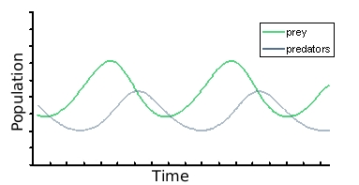
3. What are some Density Dependent limiting factors on a population?
4. What are some Density Independent limiting factors on a population?
5. What is the carrying capacity?  What is the shape of this curve?  Draw it.
6. How do limiting factors affect carrying capacity?  (ex:  food availability, competition, harsh winters)
7. What is exponential growth?  What is the shape of this curve?  Draw it.
8. What are limiting factors?
9. Label the following graphs and explain the type of growth:

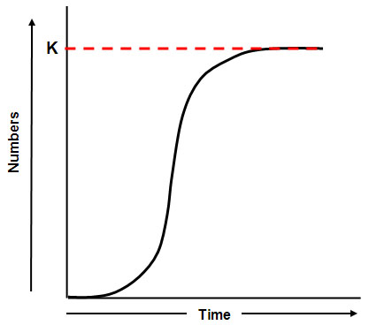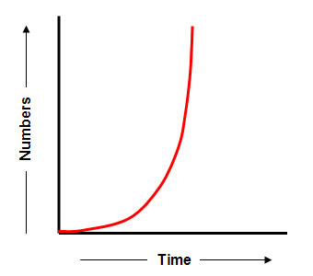

___________________________ ______________________________

1. *Study the following age diagrams. Notice which populations are growing or declining.*

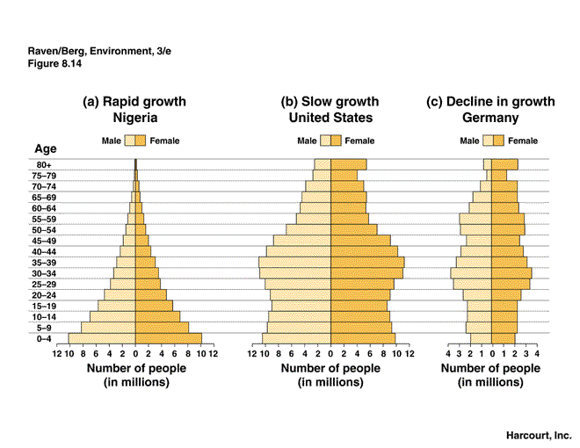

1. Analyze human population growth graphs. What type of growth curve?

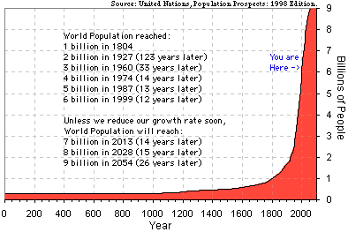

1. Factors that increase birth rates and decrease death rates:
2. How do the following effect the environment:
   1. Population size
   2. Resource use
3. Explain how the human population has caused or impacted the following:
   1. Acid rain
   2. Habitat destruction
   3. Introduction of non-native species
4. Global warming – increased carbon dioxide increases global temperature. What are some human activities that can increase carbon dioxide emissions?   
   *natural environmental processes also produce carbon dioxide – volcanoes*
5. How has the human population impacted the following (directly or indirectly)
   1. Deforestation
   2. Pesticide use –
   3. Bioaccumulation of chemicals
6. Describe the problem of ozone depletion.  What is the role of CFCs?

**Essential Standard 3**

1. Define:
   1. Phenotype
   2. Genotype
   3. Homozygous
   4. Heterozygous
   5. Monohydrid
   6. Dominant
   7. Recessive
   8. Polygenic
   9. Multiple alleles
   10. Sex-linked Traits
   11. Punnett Square
   12. Codominance
   13. Incomplete dominance
2. If a child has cystic fibrosis and his/her parents are normal, the genotypes of the parents must be ______
3. Sex-Linked Traits (colorblindness and hemophilia)  
   What are the offspring possibilities for these parents: XRXR x XrY
4. Why are males more likely to express a sex-linked recessive trait?
5. Blood types, determine parentage is possible from offspring blood type.  
   If a person is type A and her father is type O, what is her genotype? ___ _ If she has a type B son, what are the possible blood types of her husband?
6. ***Codominance/incomplete dominance****: no recessive allele, RR = red, R’R’ = white, RR’ = pink. The heterozygous is a blending or both alleles are expressed equally.*
7. ***Pedigrees*** *– determine if the pedigree is a sex-linked or normal recessive trait pedigree  
    Sex-linked – more males with disorder, only females can be carriers*

1 2 3 4

The above pedigree is for the trait hemophilia. If #2 marries a carrier female, what is their chance of having a hemophiliac daughter?

1. **Diseases**: Huntington’s Disease 🡪 late onset, nervous system disorder, dominant  
    Sickle Cell ________________________________________________________________  
    Cystic Fibrosis ______________________________________________________
2. ***Karyotype*** *– chart of chromosomes – shows the gender and chromosome abnormality (Down’s Syndrome)*
3. *Genetics vs. Environment –* ***interactive role of genetics and the environment***
   1. *Diabetes/insulin/blood sugar level (diet/exercise and genetic interaction)*
   2. *Sickle cell anemia (genetic but can be affected by low oxygen) and malaria (people that are heterozygous for sickle cell are resistant to malaria*
   3. *Lung/mouth cancer and tobacco use (increased tobacco use can increase your chance of cancer, cancers can also have a genetic link.)*
   4. *Skin cancer (can be genetic but also increased chance due to UV light), vitamin D (increased production and absorption due to UV light), folic acid (one main function is to help with fetal nervous system development and sun exposure*
   5. *PKU and diet unable to breakdown phenylalanine and can be controlled by a diet low in phenylalanine.*
   6. *Malnutrition (due to a diet low in protein and other organic molecules and nutrients)*
4. Draw the structure of a DNA nucleotide.
5. What are the four nitrogen bases found in DNA?
6. What is replication?  Where does it occur in the cell?
7. Why is DNA replication important to cells?  When does replication occur during the cell cycle?
8. What happens if there is a mistake in copying that causes a change in the DNA code?
9. How do the bases pair in the double helix (complimentary base pairing)?
10. Why is it important that the two strands of nucleotides are connected by weak hydrogen bonds?
11. Why is the sequence of nitrogen bases in DNA important?
12. What are three main differences between DNA and RNA?
13. What are the two steps of protein synthesis?
14. Where does transcription take place in the cell?  What is produced?
15. Where does translation take place?  What is produced?
16. What type of RNA carries the code for the sequence of amino acids?
17. What type of RNA supplies the amino acids during translation?
18. What kind of bond links amino acids together to form a protein?
19. Put the following steps of protein synthesis in order:

____  mRNA travels to the ribosome

____  amino acids are linked by peptide bonds to form the protein

____  transcription of DNA occurs in the nucleus to make mRNA

____  translation occurs when tRNA brings the correct amino acid to the ribosome

1. (True or False)  All cells within an organism have identical DNA?
2. Why do some cells make different proteins than others?  (Ex:  pancreas cells make insulin, while red blood cells make hemoglobin)
3. Be able to recognize symptoms of the following human conditions:
   1. Color blindness
   2. Cystic fibrosis
   3. Hemophilia
   4. Sickle Cell Anemia
   5. Down Syndrome (Trisomy 21)

                                                              i.      What does a karyotype of Down’s syndrome look like?

1. What is the Human Genome Project?
2. How is the Human Genome Project useful?
3. What is Gel Electrophoresis used for?
4. What are the uses of DNA fingerprinting?
5. What is genetic engineering?
6. What are the uses of transgenic organisms in agriculture and industry?
7. What are the ethical implications of genomics and biotechnology?
   1. Stem cell research
   2. Genetically modified organisms
8. What is the difference between biogenesis and abiogenesis?
9. How did Louis Pasteur end the debate on spontaneous generation?
10. What gases were part of early Earth’s atmosphere?  Was any oxygen present?
11. What did Urey and Miller’s experiment prove about the formation of early organic molecules?
12. What are the 5 evidences of evolution? Describe each.
13. What is variation?
14. What are examples of geographic and reproductive isolation?  How can they lead to new species evolving?
15. Discuss the evolutionary selection of resistance to antibiotics and pesticides in various species.
16. Who wrote “The Origin of Species”?
17. Who was Linnaeus?
18. What is “binomial naming”?
19. How does a dichotomous key work?
20. What evidence is used to classify organisms according to their evolutionary relationships?
21. List the seven levels of classification from the most inclusive to the least inclusive?

**Essential Standard 4**

1. Define:
   1. Carbohydrate
   2. Protein
   3. Lipids
   4. Nucleic acid
   5. Substrate
   6. Enzyme
   7. Cellular respiration
   8. Photosynthesis
2. Testing agents for the macromolecules:
   1. Simple sugars
   2. Starch
   3. Protein
   4. Lipids
3. Know the subunits of organic molecules and identify their structures:
   1. Carbohydrates:
   2. Proteins:
   3. Lipids:
   4. Nucleic Acids:
4. Use the a – d choices above as answer choices for the following:

___ provides quick energy

___ DNA and RNA

___ provides long term energy

___ Fats

___ insulation and waxy coverings on plants

___ Insulin

___ can be structural or metabolic in function

___ hemoglobin

___ enzymes

___ greatest potential energy per gram

___ lowest potential energy per gram

1. How does starch compare to glycogen, cellulose and glucose?
2. What is the function of hemoglobin?
3. *Enzymes – know about enzymes*
   1. *Speeds up chemical reactions*
   2. *Re-usable and specific*
   3. *Function best under ideal conditions (temperature and pH)*
   4. *Involved in almost all chemical reactions in body. Ex. Enzymes aid in faster food digestion.*
   5. *Read enzyme graph and be able to label enzyme reaction diagram*
4. What is a monomer?
5. What is a polymer?
6. Complete the chart for the following organic molecules:

|  |  |  |  |  |
| --- | --- | --- | --- | --- |
| Organic Molecule | Subunit/Building Block/Monomer | Function | Examples | Indicator Test Results |
| Carbohydrates |  |  |  |  |
| Lipids |  |  |  |  |
| Proteins |  |  |  |  |
| Nucleic Acids |  |  |  |  |

1. Classify the following molecules:
   1. Starch
   2. Cellulose
   3. Insulin
   4. Glycogen
   5. Glucose
   6. Enzymes
   7. Hemoglobin
   8. Fats
   9. DNA
   10. RNA
2. What are enzymes?   Draw an enzyme-substrate complex.
3. What is the function of an enzyme?
4. Are enzymes reusable?  Why is that important?
5. Why do we describe enzymes as a lock-and-key?
6. What is a denatured enzyme?  What can cause an enzyme to become denatured?
7. How does increasing temperature affect an enzymatic reaction?
8. How does lowering pH affect an enzymatic reaction?
9. What is the active site of an enzyme?  What is the substrate?
10. What can be the result of a missing or defective enzyme?
11. Draw ATP.
12. Describe the ATP-ADP cycle?
13. Where is ATP produced in eukaryotic cells?
14. What is meant by the term “aerobic”?
15. What is meant by the term “anaerobic”?
16. What is the chemical reaction for photosynthesis?
17. What organelle carries out photosynthesis?
18. What is the chemical reaction for respiration?
19. What organelle carries out aerobic respiration?
20. What are examples of organisms that use anaerobic respiration?
21. Which yields the most energy, aerobic or anaerobic respiration?
22. Compare photosynthesis and chemosynthesis.
23. Know the equation for photosynthesis:  
    and Cellular Respiration
24. What is the energy molecule for all cells?
25. Describe how cells store and use energy with ATP and ADP molecules.
26. Sunlight is transformed into chemical energy in photosynthesis. What is the chemical energy called?
27. Chemosynthesis/prokaryotes/sulfur rich sea vents   
    Evolved due to:
28. We pour hydrogen peroxide on open cuts. The peroxide mixes with the enzyme catalase (in our tissues) to produce water and oxygen. This kills bacteria because they are (aerobic or anaerobic).
29. Organelle for photosynthesis _____ _______
30. Organelle for Cellular respiration _____ ________
31. Respiration that releases the greatest amount of energy (ATP)? Aerobic or anaerobic
32. Factors that affect the rate of photosynthesis?
33. Factors that affect the rate of Cellular respiration?
34. Heart rate and breathing rate increase during strenuous exercise to increase the amount of ________ to all cells.
35. Why do athletes tire easily when competing in high altitudes?
36. Animal cell products from fermentation?
37. Yeast cell undergo alcoholic fermentation. What are the products?
38. Photosynthesis 🡪 ___________ 🡪 cellular respiration