Diagram A
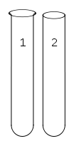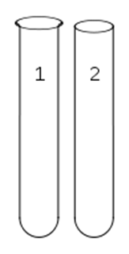
4
33

Bacteria can be separated and studied based on their oxygen consumption. To do this scientists use Thioglycolate Broth. The broth contains nutrients needed for bacterial growth and thioglycolate that sinks to the bottom due to density. The thioglycolate in the growth medium “consumes” oxygen. New oxygen continues to move into the top of the tube by diffusion. All of the tubes in our example (1-4) are filled with thioglycolate broth. A different type of bacteria will be grown in each tube.
Using this information, answer the following questions on the diagram:
- Label the section of the tubes that would have the lowest oxygen concentration. Top or Bottom?
- Label the section of the tubes that would have the highest oxygen concentration. Top or Bottom?
- If a bacteria that is an obligate anaerobe was injected into tube #1, draw dots to represent where the most bacterial growth would occur.
- If a bacteria that is an obligate aerobe was injected into tube #2, draw dots to represent where the most bacterial growth would occur.
- If a bacteria that is a facultative anaerobe was injected into tube #3, draw dots to represent where the most bacterial growth would occur.
- If a bacteria that is an aerotolerant microbe was injected into tube #4, draw dots to represent where the most bacterial growth would occur.
- Does your #3 and #4 tube look the same? They should NOT. Think about types of respiration and which type is the most efficient. Does this affect your dots?

