AP Biology pGreen Transformation Poster Instructions:
- Background
  - Describe why CaCl2 and heat-shocking bacteria are necessary for bacterial transformation (Hint: The DNA Tech power point talks about “competence”)
  - Below is a picture of the genetically engineered plasmid that you inserted into your bacteria:
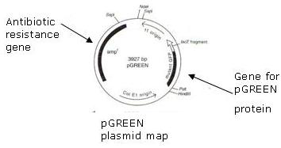
  - Describe the purpose of the antibiotic resistance gene.
  - Hypothesize about what organism gave us the pGreen gene (Hint: think about what the gene does). Explain why you think that.
  - Describe the sterile techniques that you needed to use to prevent contamination as you did the lab.
- Hypotheses/explanation
  - You should have a hypothesis about whether you should see growth on each of the plates in this lab: LB + plasmid, LB –plasmid, LB/AMP + plasmid, LB/AMP – plasmid.
  - Describe why you think that there will or will not be growth on each of these plates.
- Data-Include drawings of what happened on each plate
- Conclusions-Questions 4-10 on your lab data sheet.

