AP Biology Ecology Recovery Test
- Contrast primary and secondary succession. Why doesn’t succession look the same world-wide?

- For the age structure graph below, categorize the population as slow growth, stable, rapid growth, or decline. Describe why you characterized it that way.
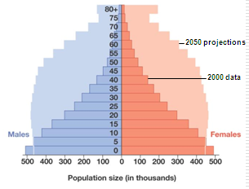

- Contrast the logistic and exponential growth models.

- Fill in the chart below:
Relationship | Characteristics of the Relationship | Example
 | Both organisms benefit
 | One benefits and another is harmed
 |  | Barnacles make their homes on whales without harming the whale
 | Two organisms are attempting to occupy the same niche
Predator/Prey

- Describe why biodiversity is so important to ecosystems. In your answer, include information on species that are more impactful than others.

- Define sustainable practice and describe 2 possible sustainable practices that humans could use.

- Match the terms and definitions
- Toxic/poisonous chemicals that plants use to avoid predation _____
- Helps the animal blend into its surroundings _____
- Organisms resembling each other _____
- Warning Coloration _____
- Looking dangerous when you are dangerous _____
- Looking like a dangerous organism when you aren’t _____

- Cryptic Coloration b. Aposomatic Coloration
c. Secondary compounds d. Mimicry
e. Batesian mimicry f. Mullerian Mimicry

- Contrast the water cycle with either the nitrogen or carbon cycle using at least 4 differences between them.

