Biology Essential Standard 1.1
Understand the relationship between the structures and functions of cells and their organelles.

Bio.1.1.1 Summarize the structure and function of organelles in eukaryotic cells:
Match these organelles with their functions:
  - Nucleus 3 1. Sites of photosynthesis, contain chlorophyll.
  - Plasma Membrane 5 2. Powerhouse of the cell, where cell respiration occurs.
  - Cell Wall 6 3. Brain of the cell, contains the DNA & chromosomes.
  - Mitochondria 2 4. Sites of protein synthesis, where mRNA & tRNA meet.
  - Vacuoles 7 5. Cell’s outer boundary, lipids & proteins, semipermeable.
  - Chloroplasts 1 6. Found in plants only to maintain structure, not semipermeable.
  - Ribosomes 4 7. Large in plants, small in animals, used for storage.

- Describe how these organelles interact with each other to perform the function of the cell:
  - Nucleus and ribosome – DNA makes mRNA in the nucleus and sends it to the ribosome
  - Plasma membrane and mitochondria – plasma membrane takes in glucose and oxygen that is needed by the mitochondria for cell respiration. The PM also releases CO2 from the process.
  - Cell wall and vacuole – as water goes into the vacuole, osmotic pressure builds up in the cell and the cell doesn’t burst due to the strength of the cell wall.
  - Cell wall and chloroplasts - since the cell wall is not semipermeable, the materials needed for photosynthesis flow freely into the cell.
- Draw a plant and animal cell and label the above organelles: please google animal cell and plant cell to check your drawings!!!
- Explain how the structure of each organelle determines it function. (Example: folded inner membrane in mitochondria increases surface area for energy production during aerobic cellular respiration).
Nucleus – the semipermeable double-layered membrane of the nucleus keeps DNA and other substances in the nucleus and other things out

Plasma membrane – the semipermeable lipid bi-layer allows certain substances into the cell and keeps other substances out

Cell wall – the cell wall’s stringy cellulose structure allows for everything to pass through while still maintaining structure when osmotic pressure increases

Mitochondria – see the question

Vacuoles – the single membrane and fluid contents of the vacuole help it store items.

Chloroplast – the double membranes of the chloroplast allow for maximum absorption of sunlight

Ribosomes – consists of 2 parts – one part allows attachment of the mRNA and the other part allows for attachment of tRNA and amino acids during protein synthesis.
- Summarize how these organelles interact to carry out life functions.(Example: DNA codes for proteins which are assembled by the ribosomes and used as enzymes for energy production at the mitochondria).
Match these:
  - energy production and use 3 1. Wastes stored in vacuole are sent to plasma membrane.
  - transport of molecules 2 2. Plasma membrane allows entrance, cytoplasm circulates.
  - disposal of waste 1 3. Mitochondria makes ATP, ribosome uses it in protein synthesis.
  - synthesis of new molecules 4 4. Nucleus sends mRNA to ribosome, tRNA brings AA to put
protein together.

- How do you determine total power magnification of a light microscope? (choose one)
  - Objective x Objective b. Ocular x Objective c. Ocular + Objective
- Which reveal greater detail about eukaryotic and prokaryotic cell differences? (choose one)
Scanning/electron transmission microscopes or light microscopes
Bio 1.1.2 Compare prokaryotic and eukaryotic cells in terms of their general structures (plasma membrane and genetic material) and degree of complexity.
  - Which are more complex, prokaryotic cells or eukaryotic cells? (circle)
  - Compare the structure of prokaryotic and eukaryotic cells. Which of these organelles are found in each type of cell? (check which are found in each)
 | Mitochondria | Nucleus | Vacuole | Chloroplasts | Ribosomes
Prokaryote |  |  |  |  | X
Eukartyote | X | X | X | X | X

 | DNA | RNA | Genetic material enclosed in nuclear membrane | Plasmids | Smaller cells | Larger cells
Prokaryote | X | X |  | X | X
Eukartyote | X | X | X |  |  | X

  - What are plasmids? Small circles of DNA that are found in bacteria and used to copy DNA during Genetic Engineering.

Bio 1.1.3 Explain how instructions in DNA lead to cell differentiation and result in cells specialized to perform specific functions in multicellular organisms.
- Compare a variety of specialized cells and understand how the functions of these cells vary:
Match these cells with their functions:
  - nerve cells 3 1. Vascular tissue in plants that carry water.
  - muscle cells 6 2. Vascular cells that carry oxygen & nutrients & fight disease.
  - blood cells 2 3. Cells which send impulses back and forth to brain and spinal cord.
  - sperm cells 4 4. The male gamete.
  - xylem 1 5. Vascular tissue in plants that carry food.
  - phloem 5 6. Cells which flex & extend (contract) to allow movement.
- Multicellular organisms begin as undifferentiated masses of cells and variation in DNA expression and gene activity determines the differentiation of cells and ultimately their specialization. (word bank - DNA, gene, undifferentiated)
- During the process of differentiation, are all parts of the DNA activated? no
  - Which parts of the DNA are activated and what do they determine? genes - they determine the function and specialize structure of a cell.
- Do all cells in an organism contain the same DNA? yes
- Do all cells initially have the potential to become any type of cell? yes – initially!
- What is the process in which the cell becomes specialized for its particular job? (choose one)
  - Crossing over b. differentiation c. natural selection
- Can cell differentiation be reversed? no
- Do all of the cells of a multicellular organism have exactly the same chromosomes? yes
  - Know this: Different parts of the genetic instructions are used in different types of cells, influenced by the cell's environment and past history.
- Can chemical signals be released by one cell to influence the development and activity of another cell? yes
  - Give an example. insulin influences other cells to take in sugar from the blood

- What is the name for cells which have not yet differentiated into various cell types? (choose one)
  - Blood cells b. bone marrow cells c. stem cells
- List 3 types of Adult Stem Cells. bone marrow, blood, adipose (fat)
- How are Embryonic stem cells different from Adult Stem Cells? when embryonic stem cells are used, the embryo is destroyed. When adult stem cells are used, the adult can regenerate more.

Biology Essential Standard 1.2
Analyze the cell as a living system.

Bio.1.2.1 Explain how homeostasis is maintained in a cell and within an organism in various environments (including temperature and pH).
- What is a solution used to stabilize the pH of a liquid? (choose one)
  - Acid b. enzyme c. base d. buffer
- Which or your cells respond to maintain temperature and how do they do this? sweat glands, hypothalamus
- Which of your cells respond to maintain glucose levels and how do they do this? pancreas, releases insulin and other hormones
- Which of your cells respond to maintain water balance and how do they do this? kidneys, filter water into and out of the blood stream
- Compare the mechanisms of active vs. passive transport: (check which apply)

 | Diffusion | Low to High Concentration | High to Low Concentration | ATP | Osmosis | With the Concentration Gradient | Against the Concentration Gradient
Active Transport |  | X |  | X |  |  | X
Passive Transport | X |  | X |  | X | X

- The movement of particles from an area of high concentration to an area of low concentration without energy being used from the cell: (choose the best choice) diffusion active transport osmosis
- The movement of water from an area of high concentration to an area of low concentration across the cell membrane without energy being used from the cell? osmosis
- Explain changes in osmotic pressure that occurs when cells are placed in solutions of differing concentrations. Can you describe what happens to cells in those different solutions:
 | Isotonic | Hypotonic | Hypertonic
Cells placed in this type of solution do not change size. | X
Cells placed in this type of solution shrink. |  |  | X
High osmotic pressure inside the cell. |  | X
Low osmotic pressure inside the cell. |  |  | X
Little to no osmotic pressure builds up inside the cell. | X
A red blood cell placed in salt water. |  |  | X
A red blood cell placed in distilled water. |  | X
A red blood cell placed in solution that simulates the blood stream. | X

Bio.1.2.2 Analyze how cells grow and reproduce in terms of interphase, mitosis and cytokinesis.
- Place these 5 steps of the cell cycle in order: (they are NOT in order):
  - Cytokinesis, Growth1 (G1), Mitosis, Growth2 (G2), Synthesis (S)
G1, S, G2, Mitosis, Cytokinesis

- Which type of reproduction uses mitosis to form the cells? asexual

- Label the PHASES and the parts of these cells in the process of mitosis and describe what is occurring in each phase.

Phase: Prophase Metaphas Anaphase Telophase
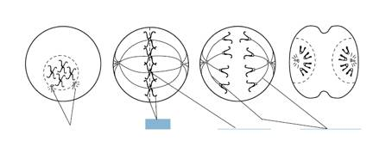
Centrioles sister chromatids centromere spindle fibers

Prophase – doubled chromosomes become visible and the centrioles appear
Metaphase – chromosomes line up on the equator in the middle of the cell, spindle fibers have formed between the centrioles
Anaphase – sister chromatids have split at the centromere and are moving to opposite poles
Telophse – chromosomes have arrived at opposite poles, cytokinesis (splitting of the cytoplasm begins)

Bio.1.2.3 Explain how specific cell adaptations help cells survive in particular environments (focus on unicellular organisms).
- Explain how various structures of unicellular organisms help that organism survive and list an organism that has these structures: (match each with their definition/examples):
 | Long whip-like tails that are used in locomotion | Extensions of the cytoplasm that are used in locomotion & nutrition. | A photo-sensitive area that detects light. | Pump excess water out of the cell. | Tiny hair-like projections that are used in locomotion & nutrition
Contractile vacuoles |  |  |  | x
Cilia |  |  |  |  | x
flagella | x
pseudopods |  | x
eyespots |  |  | x

 | Euglena, sperm cells | Paramecium, cells that line our respiratory system | Amoeba, some white blood cells | These allow euglena to be autotrophic and heterotrophic | Found in many unicellular organisms such as paramecium to help maintain osmotic balance
Contractile vacuoles |  |  |  |  | x
Cilia |  | x
flagella | x
pseudopods |  |  | x
eyespots |  |  |  | x

- Summarize adaptive behaviors of cells and give an example of each: (match)
  - Chemotaxis - 2 1. A movement toward/away from light
  - Phototaxis – 1 2. A movement toward/away from food molecules, poisons, etc.

Biology Essential Standard 2.1
Analyze the interdependence of living organisms within their environments.

Bio.2.1.1 Analyze the flow of energy and cycling of matter (such as water, carbon, nitrogen and oxygen) through ecosystems relating the significance of each to maintaining the health and sustainability of an ecosystem.
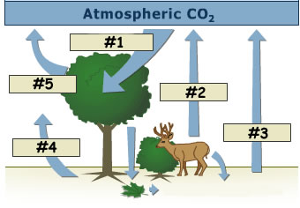
- Deconstruct the carbon cycle as it relates to photosynthesis, cellular respiration, decomposition and climate change. Label #1, 2, and 3 in this diagram using these words: respiration, photosynthesis, decomposition.
#1 – photosynthesis #2 & #5 – respiration #4 & #4 – decomposition

- Summarize the nitrogen cycle (including the role of nitrogen fixing bacteria).
  - What do nitrogen fixing bacteria convert in the nitrogen cycle? Atmospheric nitrogen to nitrates that plants can use, we then eat the plants or eat animals that have eaten the plants to get our nitrogen
  - Relate the importance of the nitrogen cycle to synthesis of proteins and DNA.
    - Which 4 main elements make up proteins? C,H,O,N
    - Which 5 main elements make up nucleic acids? C,H,O,N,P
    - Why is the nitrogen cycle important in the synthesis of proteins and DNA? We need Nitrogen to synthesize proteins and DNA since Nitrogen is found in protein and DNA!!!
- Define factors that influence climate such as:
  - greenhouse effect (relate to carbon cycle and human impact on atmospheric CO2)
    - Describe the greenhouse effect. Relate it to sitting in a car on a hot sunny day.
Due to a layer of CO2 high in the atmosphere, heat gets trapped in our atmosphere, thus raising the temperature. This is similar to sitting in a car on a hot sunny day with the windows up. The heat of the sun gets into the car but cannot escape if the windows are up.
  - natural environmental processes (relate to volcanic eruption and other geological processes)
volcanic eruptions and other geolocial processes add CO2 to the atmosphere naturally
- Explain the recycling of matter within ecosystems and the tendency toward a more disorganized state.
  - Give 2 examples of matter being recycled. Nutrients that are decomposed are used by plants for their processes. We then eat the plants or eat animals that have eaten plants and we use those same nutrients. Water is also constantly recycled in the water cycle. Carbon dioxide and oxygen are constantly recycled during the processes of photosynthesis and respiration.
  - Which 2 groups of organisms are responsible for decomposition? Fungi and bacteria
- Analyze energy pyramids for direction and efficiency of energy transfer.
  - Draw an energy pyramid. Include 4 trophic levels. Label each trophic level. Assume that the producers begin with 100,000 kj of energy. Explain the 10% rule by labeling how much energy every other level would then have. This is an example with the producers having 1000 kcals of energy:
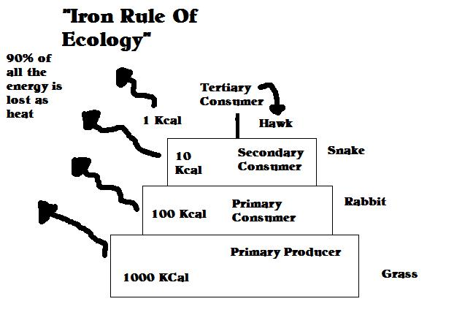
- Living systems require a continuous input of energy to maintain organization.
  - What is radiant energy? Energy from the sun
  - What is chemical energy? Energy that has been stored as chemicals such as glucose stored as starch in plants.
    - How is radiant energy converted to chemical energy? During photosynthesis plants take in sunlight and convert it into glucose
    - Which organisms are responsible for this conversion? Producers/autotrophs – plants, protists
    - What is the name of the process? photosynthesis
    - What are the end products of the process? Glucose, oxygen, and sometimes water
- Explain how energy flows through an ecosystem in relation to producers and consumers. Producers convert energy from the sun during photosynthesis. When consumers eat the producers or other consumers that have eaten producers, they get their energy.
- Which type of energy do ecosystems required a constant supply of? Radiant energy from the sun

Bio.2.1.2 Analyze the survival and reproductive success of organisms in terms of behavioral, structural, and reproductive adaptations.
- Analyze how various organisms accomplish the following life functions through adaptations within particular environments (example: water or land) and that these adaptations have evolved to ensure survival and reproductive success:
  - Transport and Excretion – how different organisms get what they need to cells; how they move waste from cells to organs of excretion.
    - How do humans transport nutrients and waste? Circulatory system (cardiovascular)
    - How do plants transport nutrients and waste? Vascular system (xylem and phloem)
    - How do humans excrete waste? Kidneys, lungs, sweat
    - How do plants excrete waste? Stomates, diffusion
  - Focus is on maintaining balance in pH, salt, and water.
    - How do organisms maintain balances in pH? Buffers (chemicals that maintain pH by releasing ions to solutions to either raise or lower the pH)
    - How do organisms maintain balances in salt? Excretion, nutrition
    - How do organisms maintain balances in water? Osmosis, excretion, nutrition
  - Include plants - vascular and nonvascular. (complete the table):
 | Xylem present | Phloem Present | Vascular Tissue present | No vascular tissue present
Vascular Plant | X | X | X
Nonvascular Plant |  |  |  | x
  - Respiration – how different organisms take in and release gases (carbon dioxide or oxygen, water vapor); cellular respiration
    - Which organs does a human use for respiration? Lungs
    - Which parts do plants use for respiration? Stomates allow carbon dioxide to enter and oxygen to leave
    - How is the releasing of gases related to cellular respiration? Oxygen is needed for aerobic cellular respiration, carbon dioxide is released in both aerobic and anaerobic respiration.
  - Nutrition – feeding adaptations and how organisms get nutrition (autotrophic and heterotrophic) and how they break down and absorb foods.
    - List 3 autotrophs plants, algae, cyanobacteria
    - List 3 heterotrophs animals, fungi, some protists
  - Reproduction, Growth and Development
    - Check which of these terms are related to sexual and asexual reproduction:
 | Mitosis | Meiosis | Seeds | Spores | Placental mammals
Sexual |  | X | X |  | X
Asexual | X |  |  | X

    - State how Sexual reproduction is different from asexual. sexual involves sex cells from two parents, asexual involves on organism dividing by mitosis
    - What are eggs? female gametes
    - What does a seed contain? plant embryo
    - What are spores? single celled reproductive unit that can give rise to a new organism without sexual fusion
      - List 2 organisms that release spores. fungi, ferns
    - What is a placenta? an organ that connects the developing fetus to the uterus. The supplies nutrients, gas exchange, and water elimination.
      - Give 3 examples of placental mammals. human, cow, dog

- Analyze behavioral adaptations that help accomplish basic life functions such as suckling, taxes/taxis, migration, estivation, and hibernation, habituation, imprinting, classical conditioning (e.g. Pavlov’s dog–stimulus association), and trial and error learning.
  - Check which of these are innate behaviors and which are learned behaviors:

 | Suckling | Taxes/taxis | Migration | Estivation | Hibernation
Innate | X | X | X | X | X
Learned

 | Classical conditioning | Trial and error learning | Habituation | Imprinting (a mixture of both types of learning)
Innate |  |  |  | X
Learned | X | X | X | X

- Match these with their definitions/examples:
  - Suckling 2 1. Instinctive seasonal movement of animals.
  - Taxes/taxis 3 2. An instinct of mammals that helps with feeding.
  - Migration 1 3. Insects moving toward light.
  - Estivation 8 4. Reduced metabolism during cold months.
  - Hibernation 4 5. An animal forms a social attachment to another object.
  - Habituation 7 6. Birds learn that grass/twigs make better nests than empty cans.
  - Imprinting 5 7. Learning by association.
  - Classical conditioning 7 8. Reduced metabolism during intense heat.
  - Trial and error learning 6 7. A learned behavior that occurs when an animal is repeatedly
given a stimulus not associated with any punishment or reward.

Bio 2.1.3 Explain various ways organisms interact with each other (including predation, competition, parasitism, mutualism) and with their environments resulting in stability within ecosystems.
- Identify and describe symbiotic relationships (give examples):
 | One organism benefits, the other is harmed | Both organisms benefit | Trichonympha live in the guts of parasites and digest cellulose | Tapeworms | Lichens (algae and fungus) | Bedbugs
Mutalism |  | X | X |  | X
Parasitism | X |  |  | X |  | X

- Exemplify various forms of communication and territorial defense including:
  - communication within social structure using pheromones (Examples: bees, ants, termites)
    - define pheromones and give an example of how these organisms use them. chemicals released by organisms for communication and mating. Queen bees release pheromones to tell the worker bees to maintain the hive, gather food, and take care of the developing larva.

  - courtship dances
    - Give an example of an organism that uses courtship dances. birds
  - territorial defense (Example: fighting fish).
    - Give 2 other examples of territorial defense. sea lions monitoring their part of the beach, cheetahs and wolves urinating to mark their territory
- Explain patterns in predator/prey and competition relationships and how these patterns help maintain stability within an ecosystem with a focus on population dynamics.

Bio.2.1.4 Explain why ecosystems can be relatively stable over hundreds or thousands of years, even though populations may fluctuate (emphasizing availability of food, availability of shelter, number of predators and disease).
- Generalizing that although some populations have the capacity for exponential growth, there are limited resources that create specific carrying capacities and population sizes are in a dynamic equilibrium with these factors. (e.g. food availability, climate, water, territory).
- Interpret various types of population graphs:
  - human population growth graphs indicating historical and potential changes
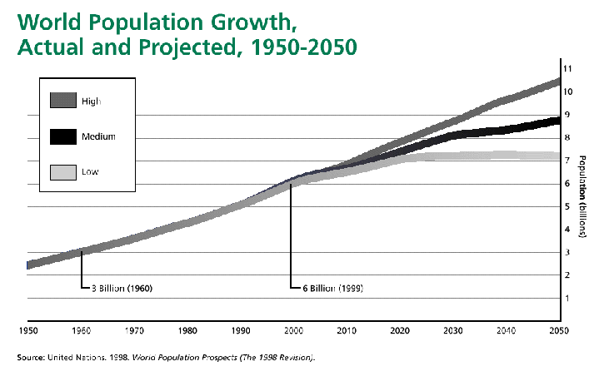

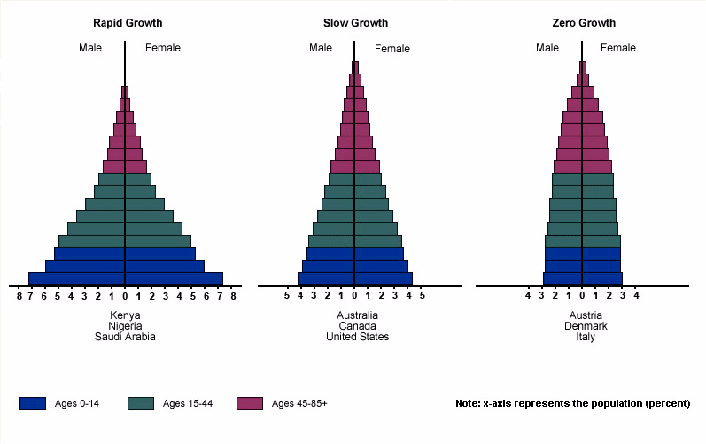
  - factors influencing birth rates and death rates
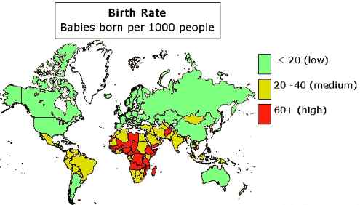

  - effects of population size
  - population density
  - resource use on the environment.

- Explain how disease can disrupt ecosystem balance. Match these examples with their definitions:
  - AIDS 4 1. an introduced species caused by a fungus & spread by elm bark beetle.
  - Influenza 3 2. associated with harmful algal blooms and fish kills in NC.
  - Tuberculosis (TB) 5 3. seasonal infectious disease caused by an RNA virus.
  - Dutch Elm Disease 1 4. final stage of HIV disease which causes severe immune deficiency
  - Pfiesteria 2 5. contagious bacterial infection that involves the lungs

- How are these diseases spread? Match them with their method:
 | AIDS | Influenza | Tuberculosis | Dutch Elm Disease | Pfiesteria
Air |  | X | X
Blood/Body fluids | X
Insects |  |  |  | X
Direct contact with the toxins released by this organism |  |  |  |  | X

- Does your risk of contracting AIDS, The Flu, and TB increase if you:
- Are in frequent contact with people who have these diseases? yes
- Have poor nutrition? yes
- Live in crowded or unsanitary living conditions? yes
Biology Essential Standard Bio.2.2
Understand the impact of human activities on the environment (one generation affects the next).

Bio.2.2.1 Infer how human activities (including population growth, pollution, global warming, burning of fossil fuels, habitat destruction and introduction of nonnative species) may impact the environment.

- Summarize how humans modify ecosystems through population growth, technology, consumption of resources and production of waste. When our population grows out of control, we harm ecosystems when we don’t conserve and follow conservation practices.
- Interpret data regarding the historical and predicted impact on ecosystems and global climate.
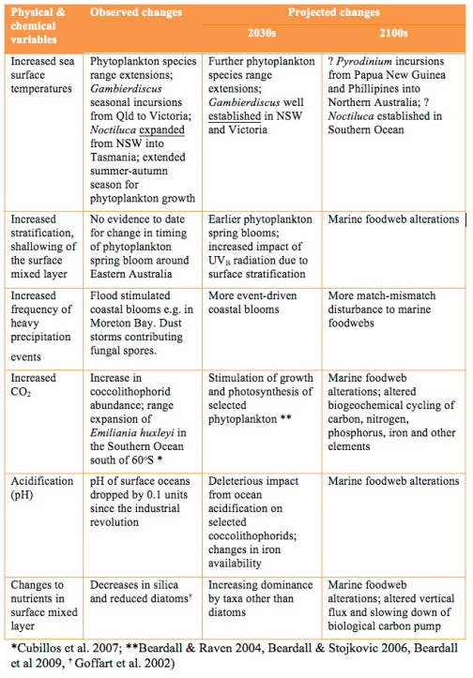
- Explain factors that impact North Carolina ecosystems.
  - How does acid rain affect the mountains of North Carolina? Red Spruce and Fraser Fir Trees are dead and dying due to acid rain. Acid rain leeches nutrients from leaves, acid rain combined with ozone can damage the waxy coating of needles and leaves. This can make the trees more susceptible to disease.
  - Is erosion a problem on NC beaches? yes If so, how are we taking care of the problem? one example is building seawalls to help prevent erosion.
  - How is urban development in the Piedmont leading to habitat destruction/water runoff and what are some of the consequences? According to the U.S. Census of Agriculture, North Carolina lost more than 600,000 acres of farmland from 2002 to 2007. The North Carolina Forestry Association says 1.1 million acres of forestland have been lost to development since 1990. Our population in the 2010 census was more than 9.5 million, an increase of 1.5 million in the first decade of the new millennium. That translates to a growth rate of 18.5 percent, the highest among Southeastern states. By 2030, our population is projected to exceed 12 million.
  - How are waste lagoons on hog farms affecting the environment? In 1995 an eight-acre hog-waste lagoon in North Carolina burst, spilling 25 million gallons of manure into the New River. The spill killed about 10 million fish and closed 364,000 acres of coastal wetlands to shellfishing.
  - How do you know that Kudzu is an invasive plant?
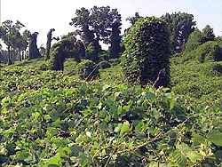

Bio.2.2.2 Explain how the use, protection and conservation of natural resources by humans impact the environment from one generation to the next.

- Explain the impact of humans on natural resources (be sure to give examples):
  - resource depletion
If nothing changes, humanity will demand 140 billion tons of minerals, ores, fossil fuels and biomass every year by 2050. This is three times our current rate of resource consumption, and far beyond what the Earth can supply.
  - deforestation – loss of biodiversity
  - pesticide use – can lead to resistance in pests
  - bioaccumulation - causes accumulation of toxins as you go up the food chain
List 5 ways you can exemplify conservation methods and stewardship: Preserving the plants, animals and natural communities through management of the lands and waters that we need to survive. Recycling one aluminum can saves enough electricity to run a television for 3 hours. In addition, we are not mining the Earth, destroying watershed or adding silt and toxic wastes to rivers by doing so. Recycling newspaper saves trees and the environment in a number of ways, including providing fish and bird habitats, cleaning CO2 and other greenhouse gases from the atmosphere, and keeping watersheds intact.

Biology Essential Standard 3.1
Explain how traits are determined by the structure and function of DNA.

Bio.3.1.1 Explain the double-stranded, complementary nature of DNA as related to its function in the cell.

• Develop a cause-and-effect model relating the structure of DNA to the functions of replication and protein synthesis:

Use these words to complete #57: genes, double helix, protein, cytosine, S phase, nitrogenous, thymine, phosphate-sugar, protein, hydrogen (Note that protein is used twice!)

- The structure of DNA is a double helix or “twisted ladder” structure. The sides are composed of alternating phosphate-sugar groups and “rungs of the DNA ladder” are composed of complementary nitrogenous base pairs.
  - Adenine (A) bonds with Thymine.
  - Guanine (G) bonds with Cytosine.
  - Which type of weak bonds holds nitrogen bases together? hydrogen
  - The sequence of nucleotides in DNA codes for protein, which is central key to cell function and life.
  - Replication occurs during the S phase of the cell cycle and allows daughter cells to have an exact copy of parental DNA.
  - Cells respond to their environments by producing different types and amounts of protein.
  - With few exceptions, all cells of an organism have the same DNA but differ based on the expression of genes.
- How is injury repair related to the overproduction or underproduction of proteins? an increase in proteins helps with injury repair
- How is cancer related to the overproduction or underproduction of proteins? Genes are the means by which a cell produces proteins, each of which have a very specific role. A mutated gene can cause overproduction of a protein, underproduction of a protein, or alteration of a protein that may be unable to carry out its purpose.

Bio.3.1.2 Explain how DNA and RNA code for proteins and determine traits.

Use these words to answer #60: functional, peptide, transcription, ribosome, protein, structural, tRNA
- Explain the process of protein synthesis:
  - transcription produces an RNA copy of DNA, which is further modified into the three types of RNA
  - mRNA traveling to the ribosome (rRNA)
  - Translation – rRNA supplies appropriate amino acids
  - Amino acids are linked by peptide bonds to form polypeptides.
  - Polypeptide chains form protein molecules.
  - Proteins can be structural (forming a part of the cell materials) or functional (hormones, enzymes, or chemicals involved in cell chemistry).

- Interpret a codon chart to determine the amino acid sequence produced by a particular sequence of bases.
  - Determine the sequence of amino acids that will result from this sequence of DNA: (google a codon chart if needed.)
    - DNA AAT TTC CGA ATG GGA
RNA UUA AAG GCU UAC CCU
AA LEU LYS ALA TYR PRO
  - Explain how an amino acid sequence forms a protein that leads to a particular function and phenotype (trait) in an organism. DNA sequences are arranged into genes. Genes express proteins, and that's what determines the phenotype.

Bio.3.1.3 Explain how mutations in DNA that result from interactions with the environment (i.e. radiation and chemicals) or new combinations in existing genes lead to changes in function and phenotype.

- Understand that mutations are changes in DNA coding and can be deletions, additions, or substitutions.
  - Define deletion – a section of DNA is lost or deleted.
  - Define addition – an extra base is added.
  - Define substitution – one base is substituted for another.

- Mutations can be random and spontaneous.
  - List 3 mutagens that can also cause mutations: chemicals, radiation, uv light
- Develop a cause and effect model in order to describe how mutations:
  - How does changing an amino acid sequence change a protein and it’s function? the arrangement of AA determines the protein formed.
  - What does this do to the phenotype of the organism? proteins determine phenotypes so a change in the amino acid sequence can change the phenotype.
- Only mutations in these can result in heritable changes: (circle the correct ones):
  - Sperm stomach liver egg skin nerve blood

Biology Essential Standard 3.2
Understand how the environment, and/or the interaction of alleles, influences the expression of genetic
traits.

Bio.3.2.1 Explain the role of meiosis in sexual reproduction and genetic variation.

- List 3 ways meiosis is different from mitosis. 1. meiosis forms gametes, mitosis deals with growth and repair of cells 2. Meiosis forms 4 cells with ½ the chromosome number of the parent cell, mitosis forms 2 cells with the same chromosome number as the parent cell 3. Two divisions occur during meiosis, one division occurs during mitosis
- What occurs during prophase I of meiosis and why is it important? crossing over provides genetic variety
- Infer the importance of the genes being on separate chromosomes as it relates to meiosis. This allows for genetic variation.
- Explain how the process of meiosis leads to independent assortment and ultimately to greater genetic diversity. Mendel's law of independent assortment states that allele pairs separate independently during the formation of gametes.

- Exemplify sources of genetic variation in sexually reproducing organisms including: (give examples if you are able):
  - crossing over – occurs during prophase I of meiosis – chromosomes exchange segments. This allows for genetic variation in chromosomes that are passed on to the gametes.
  - random assortment of chromosomes – this ensures that genes sort independently
  - gene mutation – some mutations cause changes in proteins and therefore cause a change in the phenotype
  - nondisjunction – chromosomes do not separate properly during anaphase I or anaphase II of meiosis. This can create a gamete that has either too many chromosomes or not enough chromosomes.
  - fertilization – this ensures that a new blending of genes will occur.

- Compare meiosis and mitosis including type of reproduction (asexual or sexual), replication and separation of DNA and cellular material, changes in chromosome number, number of cell divisions, and number of cells produced in a complete cycle. Complete the table:
 | Sexual or asexual reproduction | Is DNA replicated? | Changes in chromosome number from parent to daughter cells? | Number of cell divisions: | Number of daughter cells produced:
Mitosis | Asexual | Yes | Same number | 1 | 2
Meiosis | Sexual | Yes | ½ the number | 2 | 4

Bio.3.2.2 Predict offspring ratios based on a variety of inheritance patterns (including dominance, co-dominance, incomplete dominance, multiple alleles, and sex-linked traits).

- Interpret Punnett squares (monohybrid only) to determine genotypic and phenotypic ratios.
  - In rabbits, black fur is dominant over white fur. Show the cross of a heterozygous black male with a homozygous white female. Bb x bb = 2 Bb and 2 bb
  - Blue eyes are dominant to red eyes in rabbits. Show a heterozygous blue-eyed rabbit crossed with a red-eyed rabbit. Rr x rr = 2 Rr and 2 rr
- Understand that dominant alleles mask recessive alleles.
  - Determine parental genotypes based on offspring ratios:
    - In humans, brown eyes (B) are dominant over blue (b). A brown-eyed man marries a blue-eyed woman and they have three children, two of whom are brown-eyed and one of whom is blue-eyed. Draw the Punnett square that illustrates this marriage. What is the man’s genotype? He is Bb. What are the genotypes of the children? Bb and bb
  - Interpret karyotypes (gender, and chromosomal abnormalities). What is the gender of this child? male Which genetic disorder does this child have? Down Syndrome

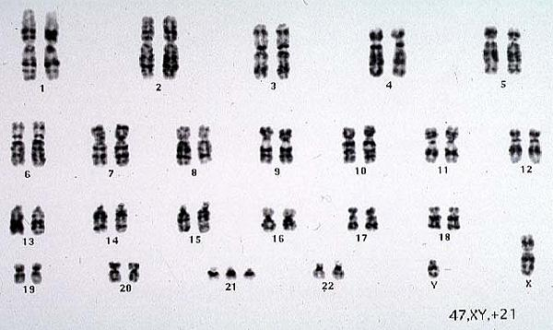

  - Recognize a variety of intermediate patterns of inheritance (codominance and incomplete dominance).
    - Think pINC – incomplete dominance (red x white snapdragons = pink snapdragons)
    - Think COw – codominance (red cow x white cow = roan cow)
  - Recognize that some traits are controlled by more than one pair of genes and that this pattern of inheritance is identified by the presence of a wide range of phenotypes (skin, hair, and eye color).
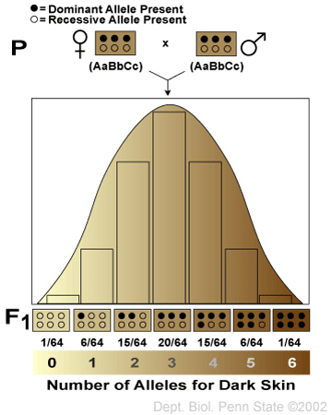
  - Interpret autosomal inheritance patterns: sickle cell anemia including the relationship to malaria (incomplete dominance), cystic fibrosis (recessive heredity), and Huntington’s disease (dominant heredity).
    - Explain sickle cell anemia’s relationship to malaria due to incomplete dominance.
People that are heterozygous for Sickle Cell are immune to malaria so the gene has stayed in the gene pool.
    - Explain how two normal parents could have a child with cystic fibrosis. Both of them could carry the recessive trait. In other words they would be heterozygous.
    - What are some of the symptoms of Huntington’s disease? late onset (people don’t show symptoms until their 40s), it is a brain disorder that causes uncontrolled movements, emotional problems, and loss of thinking ability
  - Solve and interpret codominant crosses involving multiple alleles including blood typing problems. (Blood Types: A, B, AB and O and Alleles: IA, IB, and i). Students should be able to determine if parentage is possible based on blood types.
    - Pretend that Brad Pitt is homozygous for the type B allele, and Angelina Jolie is type “O.” What are all the possible blood types of their baby? B
      - Two parents think their baby was switched at the hospital. It’s 1968, so DNA fingerprinting technology does not exist yet. The mother has blood type “O,” the father has blood type “AB,” and the baby has blood type “B.” Complete a Punnett square showing all possible genotypes for children produced by this couple
        - Mother’s genotype: oo
        - Father’s genotype: AB
        - Baby’s genotype: Bo
        - Punnett square showing all possible genotypes for children produced by this couple
        - Was the baby switched? no
  - Understand human sex chromosomes and interpret crosses involving sex-linked traits (color-blindness and hemophilia).
    - Why are males more likely to express a sex-linked trait? because they have only 1 X chromosome
    - Colorblindness is inherited as a sex-linked recessive disease. An affected male marries a heterozygous female. Draw a Punnett square of the possible offspring.
X^{c}Y x X^{C}X^{c} What is the chance that they will have an affected child? 50 percent Could any of their daughters be affected? yes – 1/2
  - Interpret phenotype pedigrees to identify the genotypes of individuals and the type of inheritance:
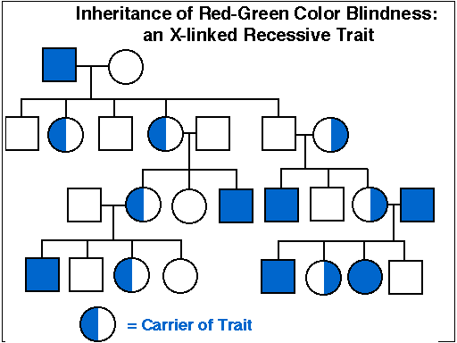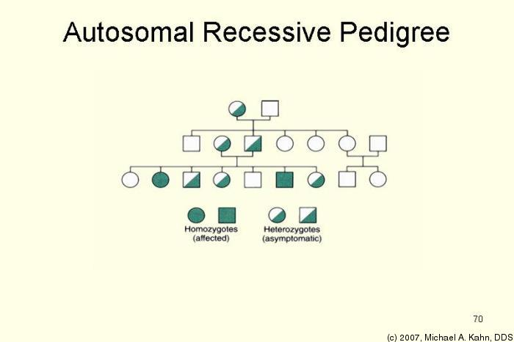

Bio.3.2.3 Explain how the environment can influence the expression of genetic traits.

- Develop a cause-and-effect relationship between environmental factors and expression of a particular genetic trait. Examples include the following: (Match each with the environmental cause.)
  - lung/mouth cancer 3 1. diet/exercise and genetic interaction
  - skin cancer 5 2. diet/exercise and genetic interaction
  - diabetes 1 or 2 3. tobacco use
  - PKU 4 4. diet
  - heart disease 1 or 2 5. vitamin D, folic acid and sun exposure

Biology Essential Standard 3.3
Understand the application of DNA technology.

Bio.3.3.1 Interpret how DNA is used for comparison and identification of organisms.
- Summarize the process of gel electrophoresis as a technique to separate molecules based on size. Students should learn the general steps of gel electrophoresis
  - What are used cut DNA into different sized fragments? restriction enzymes
  - Which fragments move more slowly, the long ones or the short ones? long
- Interpret or “read” a gel: Which suspect should be questioned about the crime? suspect 2 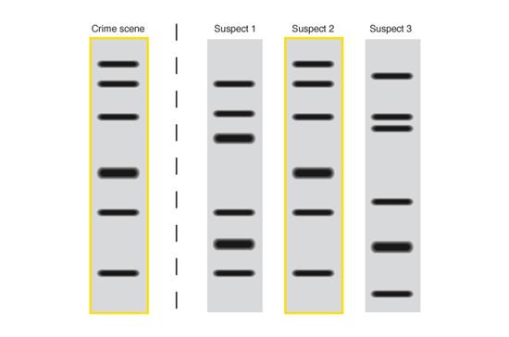
- Exemplify applications of DNA fingerprinting:
  - How can DNA fingerprinting identify individuals? match the bands
  - How can DNA fingerprinting be used to identify and catalog endangered species. match the bands

Bio.3.3.2 Summarize how transgenic organisms are engineered to benefit society.
- Generalize the applications of transgenic organisms (plants, animals, & bacteria) in agriculture and industry including pharmaceutical applications such as the production of human insulin. Which of these can be produced by transgenic organisms?

 | Human insulin | Antibodies | Hormones | Vaccines | Enzymes
Produced by transgenic organisms? | Yes | Yes | Yes | Yes | Yes

- Summarize the steps in bacterial transformation (insertion of a gene into a bacterial plasmid, getting bacteria to take in the plasmid, selecting the transformed bacteria, and producing the product).
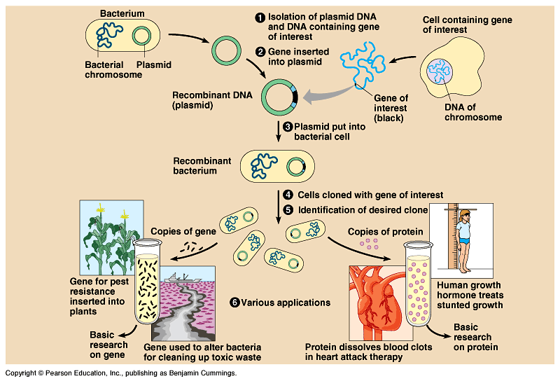

Bio.3.3.3 Evaluate some of the ethical issues surrounding the use of DNA technology (including cloning, genetically modified organisms, stem cell research, and Human Genome Project).
- Identify the reasons for establishing the Human Genome Project.
  - Recognize that the project is useful in determining whether individuals may carry genes for genetic conditions and in developing gene therapy.
  - Evaluate some of the science of gene therapy. (e.g. Severe Combined Immunodeficiency and Cystic Fibrosis) Gene therapy with Cystic Fibrosis involves the lungs
- Critique the ethical issues and implications of genomics and biotechnology:
  - stem cell research
  - gene therapy
  - genetically modified organisms

Biology Essential Standard 3.4
Explain the theory of evolution by natural selection as a mechanism for how species change over time.

Bio.3.4.1 Explain how fossil, biochemical, and anatomical evidence support the theory of evolution.
- Summarize the hypothesized early atmosphere and experiments that suggest how the first “cells” may have evolved and how early conditions affected the type of organism that developed
(use these words: multicellular, eukaryotic, prokaryotic, anaerobic, photosynthetic)
  - First organisms were believed to be: anaerobic and prokaryotic.
  - They were then photosynthetic.
  - Then eukaryotic.
  - And then multicellular.
- Summarize how fossil evidence informs our understanding of the evolution of species and what can be inferred from this evidence.
  - Where are the more primitive organisms found – in the lower strata or upper strata?
  - Where are the more derived traits located – in the lower strata or upper strata?
  - Please analyze the diagram and answer the questions for #18 below:
    - sediment and organisms moved into the area (succession)
    - they did not have bones, shells, or tissues that formed fossils
    - the fossils are 425 million years old, B is older, D is younger
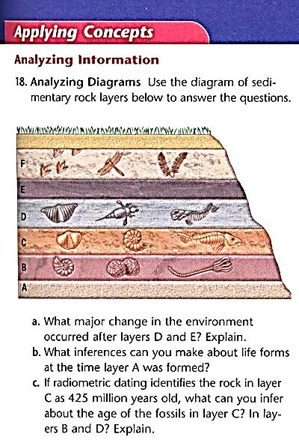

- Generalize what biochemical (molecular) similarities tell us about evolution. Which of these organisms are most closely related? Human and chimpanzee (the sequences match)
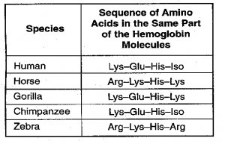
- Generalize what shared anatomical structures (homologies) tell us about evolution. They tell us that those organisms possibly came from common ancestors.
Bio.3.4.2 Explain how natural selection influences the changes in species over time.
- Who developed the concept of natural selection? Charles Darwin
- Develop a cause and effect model for the process of natural selection. Explain what each of these statements mean:
  - Species have the potential to increase in numbers exponentially. Due to reproduction, species produce more organisms than will survive due to limited resources.
  - Populations are genetically variable due to mutations and genetic recombination. Crossing over and fertilization lead to genetic recombination.
  - There is a finite supply of resources required for life. Resources are limited so therefore organisms compete for them. .
  - Changing environments select for specific genetic phenotypes.
  - Those organisms with favorable adaptations survive, reproduce and pass on their alleles.
  - The accumulation and change in favored alleles leads to changes in species over time.
  - Illustrate the role of geographic isolation in speciation. When organisms become geographically isolated, they have different selective pressures and after many years new species may arise.

Bio.3.4.3 Explain how various disease agents (bacteria, viruses, chemicals) can influence natural selection.
- Develop a cause and effect model for the role of disease agents in natural selection including evolutionary selection of resistance to antibiotics and pesticides in various species, passive/active immunity, antivirals and vaccines.
  - Explain why some bacteria are resistant to antibiotics. Due to over-use of antibiotics and people not taking the full course of antibiotics when instructed, the weaker bacteria die and the stronger bacteria survive and are resistant to certain antibiotics.
  - Explain why some insects are resistant to pesticides. Over application of pesticides
  - Complete this table by checking the related terms (some may have more than 1 checkmark!)
 | Passive immunity | Active Immunity | Antivirals | Vaccines | Antibiotics
Life lasting immunity |  | X
Short term immunity | X
Destroy the cell walls of bacteria |  |  |  |  | X
Slow growth of viruses |  |  | X
Dead/weakened pathogens |  |  |  | X
Contracting chicken pox or the measles |  | X
A mother breast-feeding her child | X
Biology Essential Standard 3.5
Analyze how classification systems are developed upon speciation.

Bio.3.5.1 Explain the historical development and changing nature of classification systems.
- Generalize the changing nature of classification based on new knowledge generated by research on evolutionary relationships and the history of classification system.
  - How many kingdoms of organisms did the first classification system (Aristotle and Linnaeus) have and what where the categories? 2 – plants and animals
  - How many kingdoms did the next classification system have and what where the categories? 5 – Animals, Plants, Fungi, Protists, Bacteria
  - How many kingdoms are in the current classification system? 6 (and they’re working on a 7th) Which kingdom was split from the previous system? bacteria was split into eubacteria and archaebacteria
  - Which category is now above a kingdom and how many are there? Domains – 3 – Eukarya, Archaea, Bacteria
Bio.3.5.2 Analyze the classification of organisms according to their evolutionary relationships (including dichotomous keys and phylogenetic trees).
- Classify organisms using a dichotomous key. Classify these leaves.
I is Betula II is Aesculus III is Carya IV is Liquidambar V is Cercis VI is Magnolia
VII is Robinia
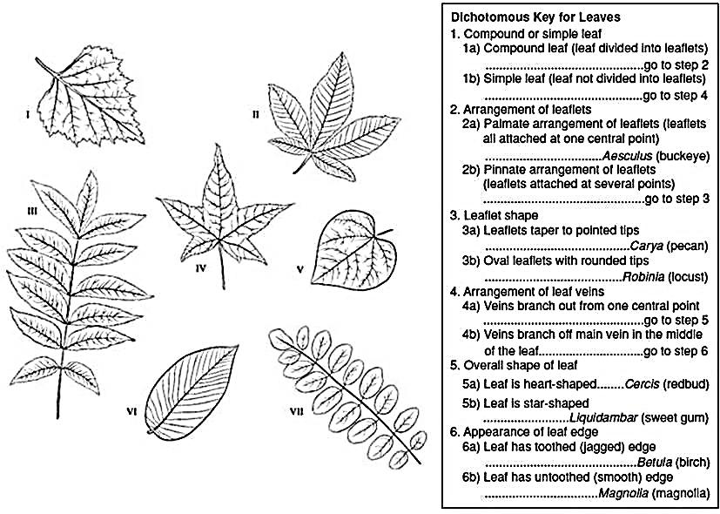

- Compare organisms on a phylogenetic tree in terms of relatedness and time of appearance in geologic history.

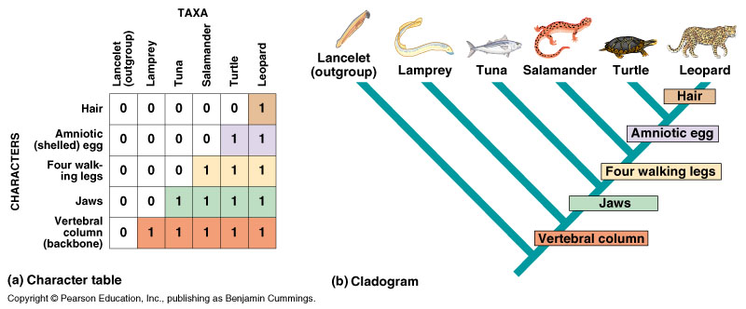

Biology Essential Standard 4.1
Understand how biological molecules are essential to the survival of living organisms.

Bio.4.1.1 Compare the structures and functions of the major biological molecules (carbohydrates, proteins, lipids, and nucleic acids) as related to the survival of living organisms.
- Compare the structure and function of each of the listed organic molecules in organisms. Check which are examples or are related to these biological molecules:
 | Insulin | Glucose | Cellulose | DNA | Hemoglobin | Steroids | Starch | Enzymes | hemoglobin
Carbohydrate |  | X | X |  |  |  | X
Lipid
Protein | X |  |  |  | X | X |  | X | X
Nucleic Acid |  |  |  | X

 | Glycogen | RNA | phospholipids | Hexagon shape | Amino Acids | Protein synthesis | Denature | Cell membranes | Quick Energy
Carbohydrate | X |  |  | X |  |  |  |  | X
Lipid |  |  | X |  |  |  |  | X
Protein |  |  |  |  | X |  | X | X
Nucleic Acid |  | X |  |  |  | X

  - Carbohydrates
    - What is the function of glucose? quick energy
    - What is the function of cellulose and where is it found? structure in the cell walls of plants
    - Where is starch stored in plants? roots and stem
    - What is glycogen and how is it related to starch? glycogen is excess glucose that is stored in the liver or animals (plants store their glucose as starch)

  - Proteins
    - What is the function of insulin and where is it produced? insulin causes your cells to absorb sugar from the blood. It is produced in the pancreas.
    - What is the function of enzymes? biological catalysts that speed up and lower activation energy of chemical reactions.
    - What is the function of hemoglobin and where is it found? hemoglobin helps your red bloods cells carry oxygen in the blood
  - Lipids
    - What is the function of phospholipids/where are they found? along with proteins, phospholipids make up the bi-layer structure of cell membranes
    - Why are steroids important to our bodies? many of our hormones are steroid hormones. Cholesterol is another example of a steroid we have in our bodies. A lot of the other steroids we have in our bodies are derived from cholesterol.
  - Nucleic Acids
    - What is the function/purpose of DNA? DNA is our genetic code.
    - What is the function/purpose of RNA? RNA helps with protein synthesis

Bio.4.1.2 Summarize the relationship among DNA, proteins and amino acids in carrying out the work of cells and how this is similar in all organisms.
- Recall that the sequence of nucleotides in DNA codes for specific amino acids which link to form proteins.
  - List the amino acid sequence that would result from this DNA base sequence:
DNA A-A-G - G-A-T - C-C-G
mRNA U-U-C C-U-A G-G-C
AA PHE LEU GLY
mRNA Codon | Amino Acid
A-G-A | ARG
C-U-A | LEU
G-G-C | GLY
U-U-C | PHE

  - What part of an amino acid makes it different from other amino acids if they all have similar structures and elements? The R (radical) group or what is called the side chain. All of the side chains are different and determine which amino acid is which.
  - List the five nitrogenous bases found in nucleic acids. Adenine, Thymine, Guanine, Cytosine, Uracil
  - Are these five bases the same for all organisms? YES!

- Summarize the process of protein synthesis. Label this diagram:
M is DNA, N is mRNA, O is the DNA template that is used to make mRNA, P is an Amino Acid,
Q is tRNA, R is the ribosome, X and Z are codons

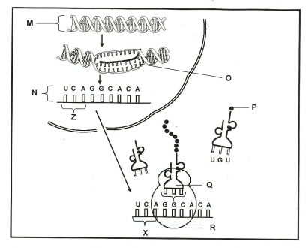

Bio.4.1.3 Explain how enzymes act as catalysts for biological reactions.
- Develop a cause and effect model for specificity of enzymes.
  - Explain how/why enzymes are specific by using the example of eating a cracker vs. a piece of meat.
    - Why will the enzymes that break down a cracker not break down meat? salivary enzymes containing amylase are found in our mouth. Amylase breaks down starch (amylose) and not protein. Amylase has a specific structure that allows it to attach only to amylase (starch). Therefore, we have to chew meat over and over before we swallow it and it seems like a cracker eventually melts in our mouth.

Please use this word bank to answer the next questions:
all, lower, pH, re-usable, 3-D, speed up, temperature, specific, catalysts

  - The folding of proteins produces a 3-D shape that is linked to function.
  - Enzymes are proteins that speed up chemical reactions. Because of this, enzymes are called catalysts.
  - Enzymes lower the activation energy of a reaction.
  - Enzymes are specific and reusable. Remember that the shape of an enzyme determines which substrates it can react with.
  - Enzymes are affected by factors such as temperature and pH.
  - Describe the lab that we performed that showed how these factors affect enzymes. When we boiled liver, we saw that the catalase enzyme found in the liver was denatured and would not cause the hydrogen peroxide to bubble. We also saw this when we put the liver in Hydrochloric Acid and Sodium Hydroxide…they high and low pH also denatured the catalase enzyme in the liver.
  - Enzymes are necessary for ALL biochemical reactions!

Biology Essential Standard 4.2
Analyze the relationships between biochemical processes and energy use in the cell.

Bio.4.2.1 Analyze photosynthesis and cellular respiration in terms of how energy is stored, released, and transferred within and between these systems.

- Analyze overall reactions including reactants and products for photosynthesis and cellular respiration and factors which affect their rates.
  - Write the equation for photosynthesis.
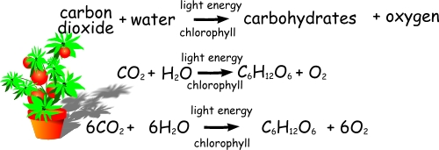
  - Write the equation for cellular respiration.
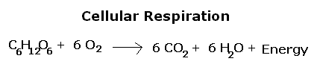
  - How would low levels of carbon dioxide or water affect the rate of photosynthesis? low carbon dioxide levels and water levels lower the rate of photosynthesis; higher levels increase the rate.
  - How would high levels of oxygen and glucose affect the rate of cellular respiration? higher levels = higher rate of cellular respiration
  - How would temperature affect photosynthesis and cellular respiration? really high temperatures and really low temperatures will affect photosynthesis and respiration due to the fact that the enzymes being used during those reactions would denature.
  - How would pH affect photosynthesis and cellular respiration? low and high pH levels could denature the enzymes involved in the reactions
  - How does the amount of light affect photosynthesis? more light usually means a higher rate of photosynthesis.

- Compare these processes with regard to efficiency of ATP formation, the types of organisms
using these processes, and the organelles involved.
  - Which organisms perform photosynthesis? plants, algae, cyanobacteria
  - Which organelles are involved? chloroplasts
  - Which organisms perform cellular respiration? ALL
  - Which organelles are involved? cytoplasm and mitochondria
  - How is anaerobic respiration different from aerobic respiration? anaerobic occurs in the absence of oxygen
  - What is another name for anaerobic respiration? fermentation
  - In which organisms does lactic acid fermentation occur? muscle cells of animals
  - In which organisms does alcoholic fermentation occur? yeast
  - How many ATP are produced in aerobic respiration compared to anaerobic respiration? 36 are produced in aerobic, 2 are produced during anaerobic.

Bio 4.2.2 Explain ways that organisms use released energy for maintaining homeostasis (active transport).
- Conclude that energy production by organisms is vital for maintaining homeostasis and that maintenance of homeostasis is necessary for life.
  - Why do cells use active transport? sometimes there are chemicals that they need or need to rid of, but those chemicals are in a lower concentration compared to where they need to go.
  - What do cells need in order to perform active transport? energy (ATP)
  - List 1 thing cells rid of during active transport and give an example of this in your body.
In the human body, active transport takes place in the small intestine during digestion of food. The kidneys use active transport to move urea and nitrogen from the blood. low concentration of urea in the blood to a higher concentration in the kidneys.
  - List 3 reasons why organisms use the process of locomotion. food, escape from predators, find mates, find shelter
  - List 3 molecules that your body is synthesizing right now. protein, DNA, enzymes

